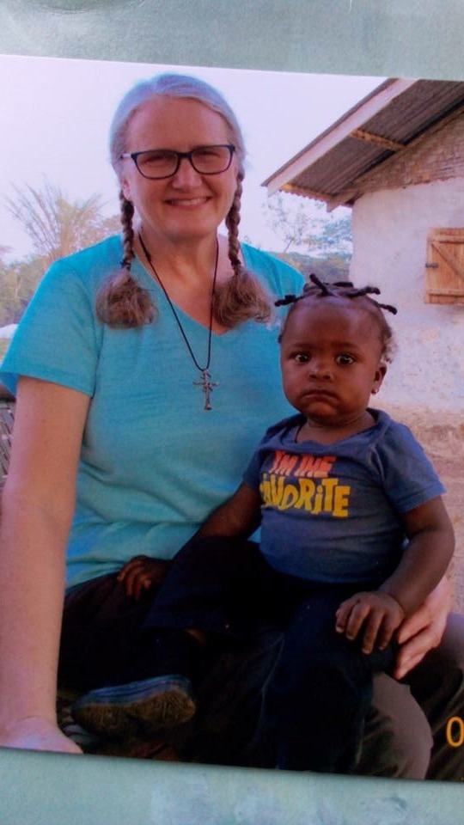It is with sad but grateful hearts that we say goodbye to our CEO, Cindy Bye, who has resigned from the Kuwaa Mission - Board of Directors, effective the end of June, 2018.

Cindy  has been a volunteer for the Kuwaa Mission since 2009. In June of that year, Cindy first learned about the Kuwaa Mission when at her church in Anchorage, Alaska, she heard a presentation about the Mission by Rev. Dr. Richard Thompson, a former missionary with the Kuwaa, and Mr. Stan Olsen, a construction manager with experience in Liberia.  At that moment she felt a calling to volunteer and join the Mission. By the end of 2009 Cindy made her first trip to Liberia with her college age daughter, Bekki,

Over the next 9 years, Cindy would travel to Liberia a total of 7 times, working alongside the Kuwaa people installing water wells to bring safe drinking water to the villages and improve their sanitary conditions.  As a retired water treatment engineer, Cindy believes that everyone has the right to safe clean water. The Kuwaa came to love Cindy, referring to her as Ma Sombee and even having a baby girl named after her.

Cindy says, “The most important lesson that I have learned from the Kuwaa is about the value of relationships. Material things and even the adventure and entertainment we seek do not make us truly happy. The true joy is in relationships. As Jesus said in John 15, ‘I tell you these things so that my joy may be in you, and your joy may be complete.’”

We give thanks to the Lord for Cindy and her dedication to the Kuwaa Mission and the Kuwaa people. We wish her God’s richest blessings as she moves forward with new callings in ministry for our Lord and Savior, Jesus Christ.

[](https://smile.amazon.com/)Karen Voris,

Kuwaa Mission Board Member

**Your contributions to The Kuwaa Mission are tax-deductible.  We are a 501c3 non-profit organization.  Our Tax ID number is 27-5458111**