I returned home early February after a successful trip to Liberia in January. All of our work projects are well underway with competent and trustworthy Liberian’s overseeing the work.

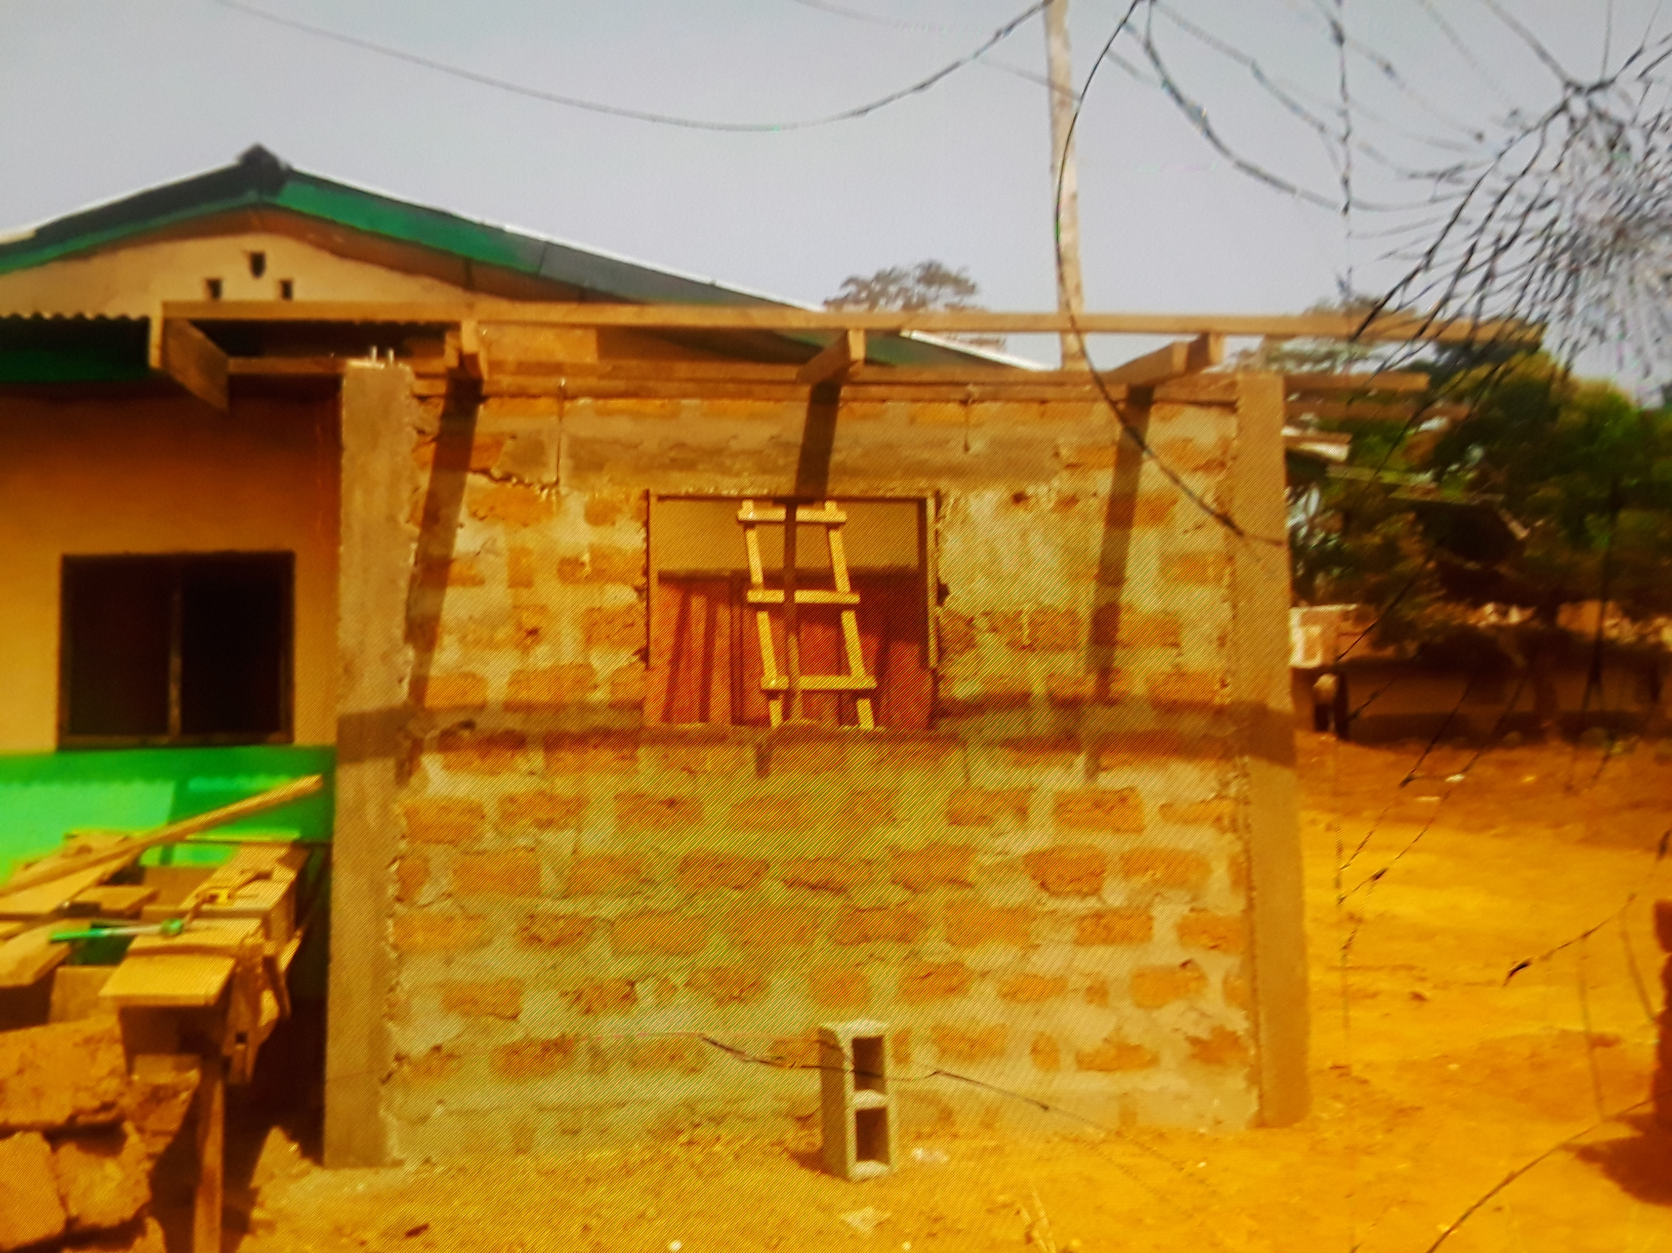
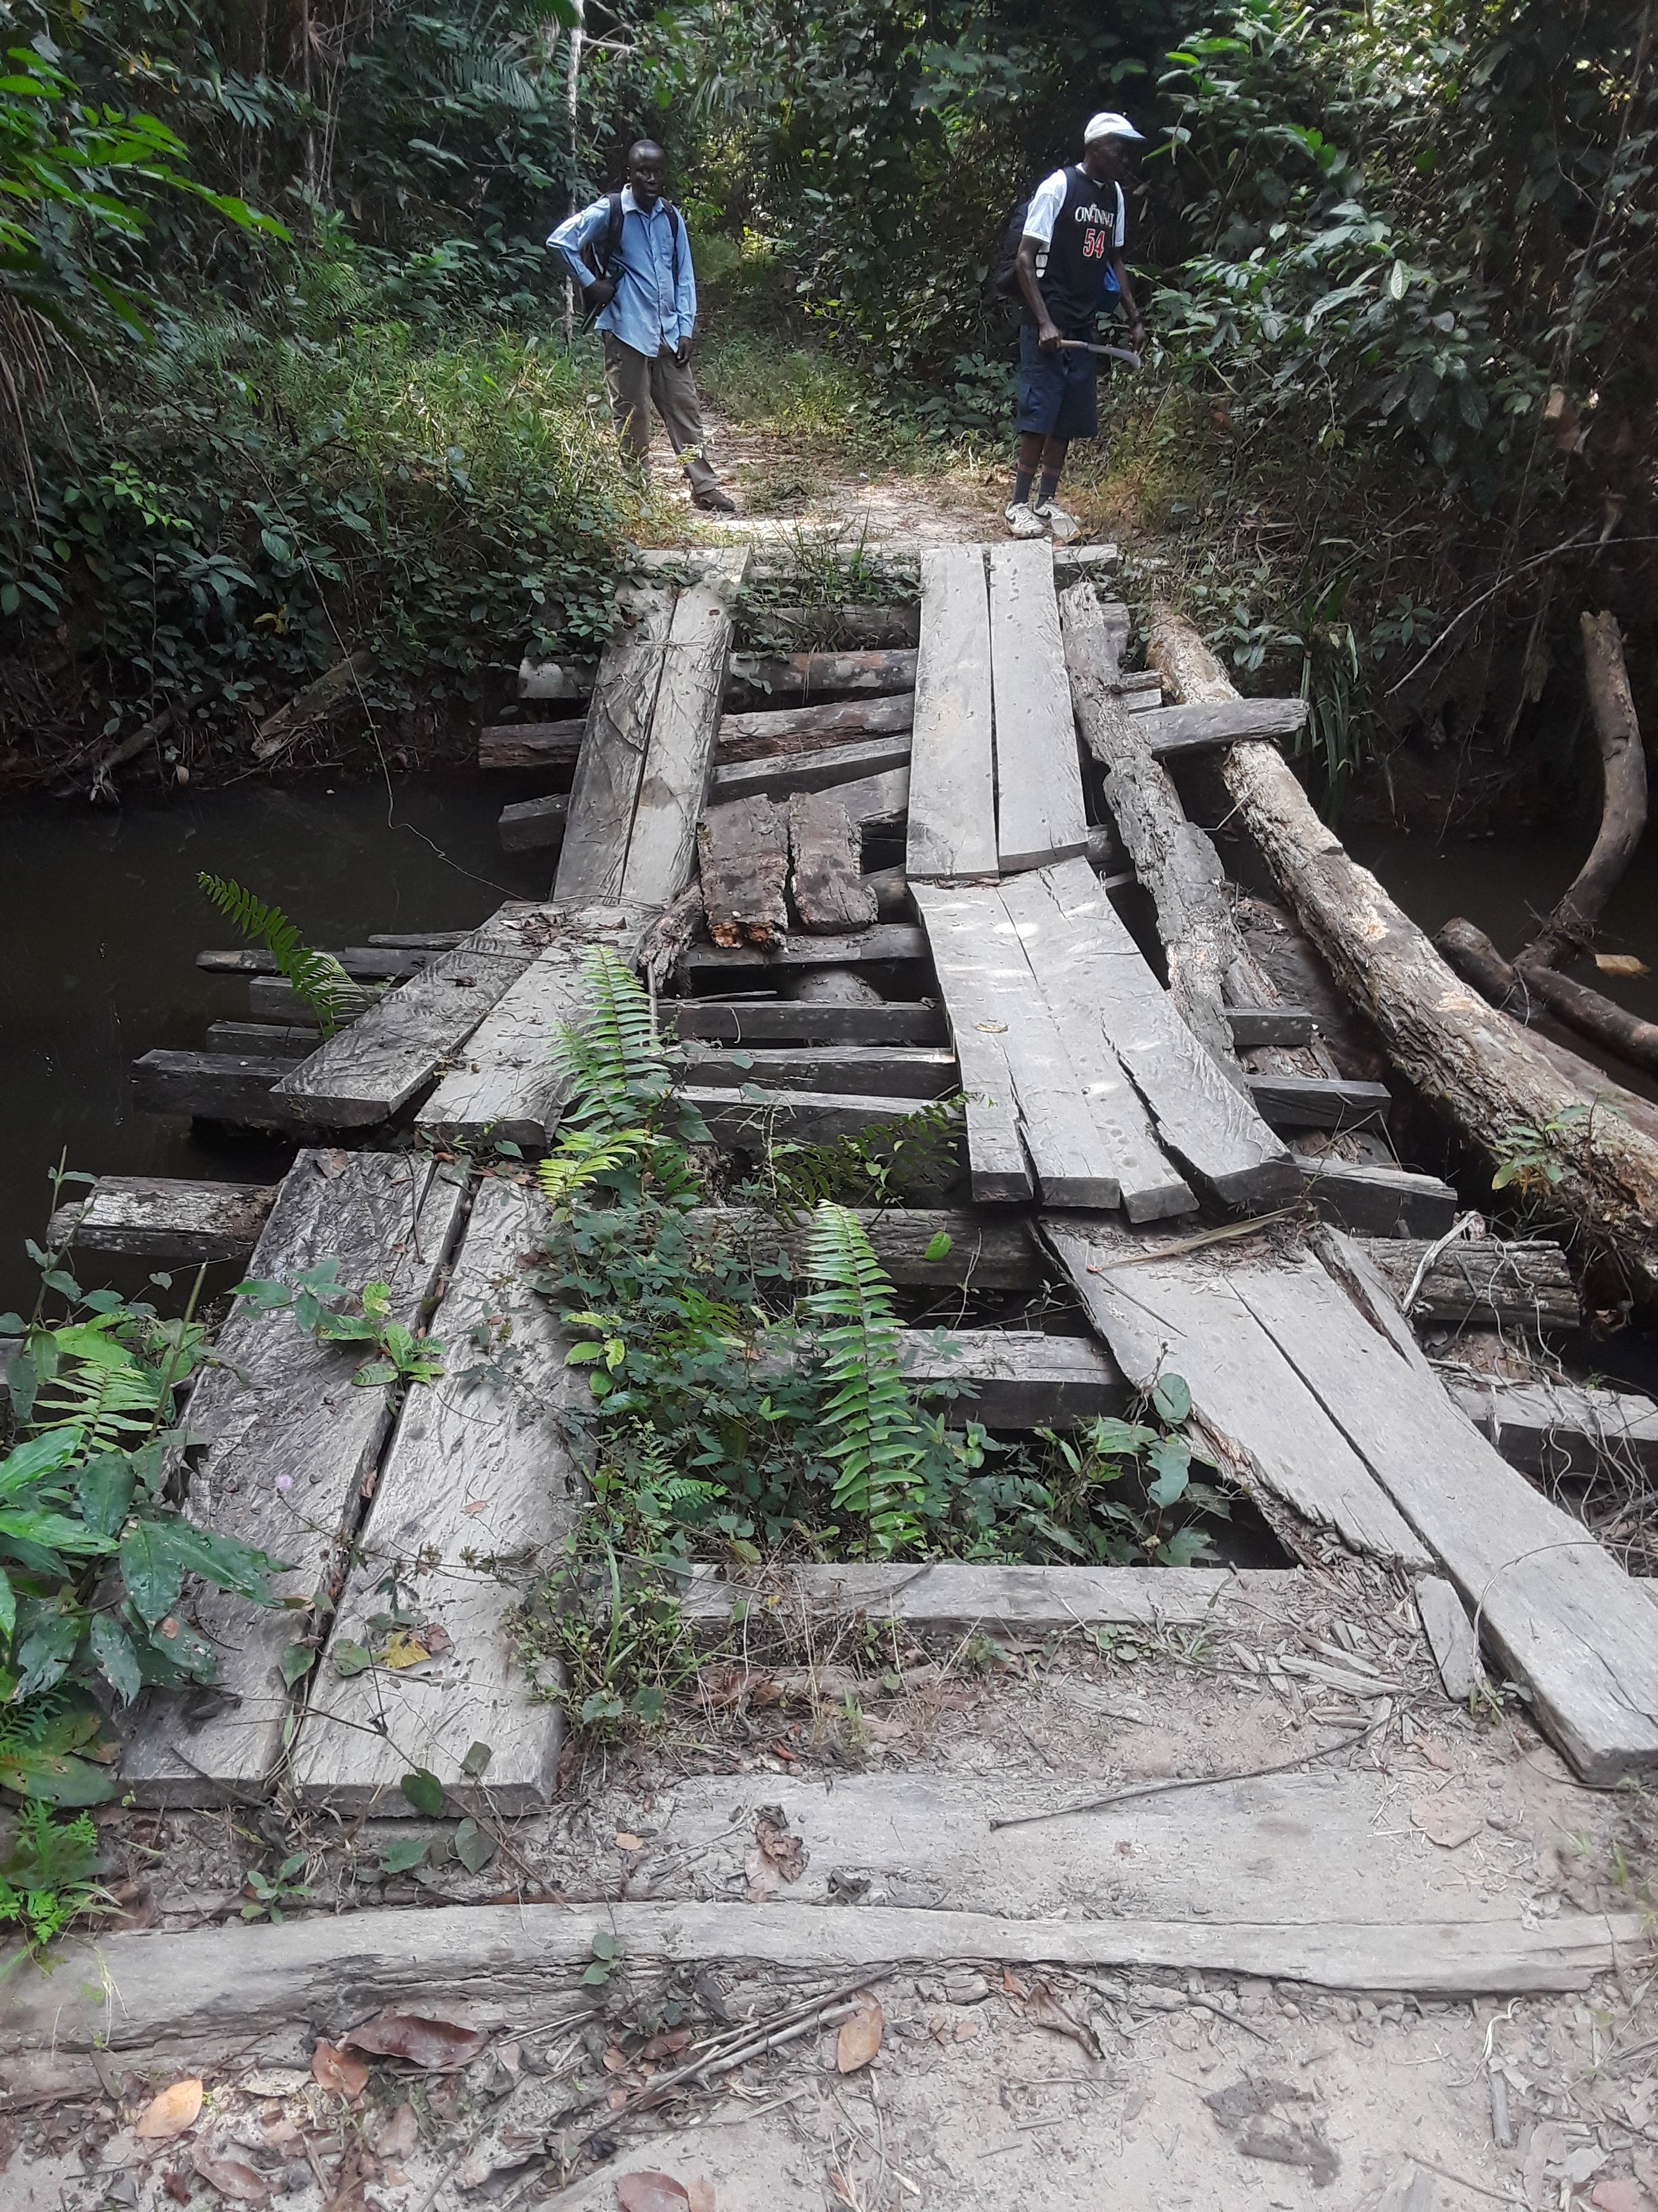
This year we are finishing work on about 30 bridges of various lengths between the end of the main road into the Kuwaa Chiefdom all the way to the clinic. Motorbikes can travel to the clinic but even then the bridges are questionable. Our goal is make them useable for a pickup truck. Emmanuel from Lowoma is spearheading the effort. Last year we cut most of the timber and planks and now we are cutting the logs that will be hauled by hand to make the initial span crossing. The people in the villages will do the actual work.

To the clinic in Kondesu we are adding a storeroom, an incinerator and an awning over one of the entrances to provide cover for the patients from the rain during the rainy season and from the sun during the dry season.

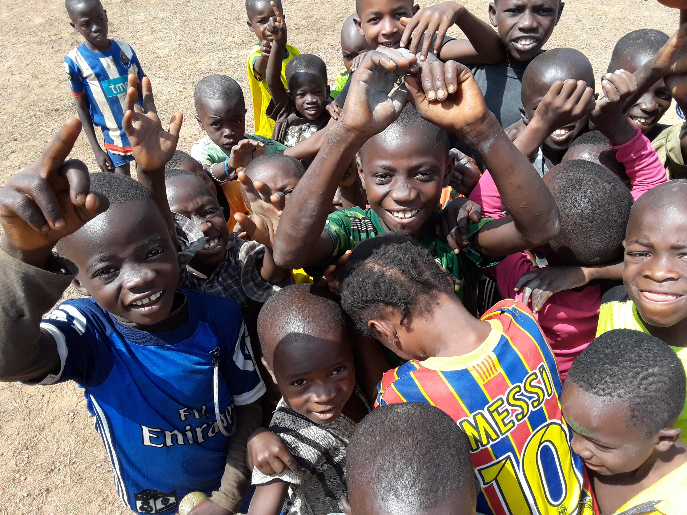
Another very successful Children’s Bible School was held in Mauvordor by Korpu Barsay and Rev. Paye. Well over 100 children were in attendance. Korpu also conducted a community sanitation program while there. We have noticed that over the past 4 years the villages are much cleaner than before we started the program.

We have sent evangelists to Totota for training where the Lutheran Church in Liberia (LCL) has “Lay Training Center”. They are very enthusiastic about the program. It takes place over two years with a 9 week training session occurring twice each year. Typical topics include: Reformation, Pauline letters,
Church history, speaking, Lutheran theology and many other topics. They all sound interesting and all classes are led by Lutheran Pastors.

I was able to walk between many villages this year and enjoyed visiting with the people. It was very rewarding to see people of different faiths, especially the Muslims and Christians, working side by side on their respective churches, mosques and other community projects around their village. There are NO conflicts between these religious groups.

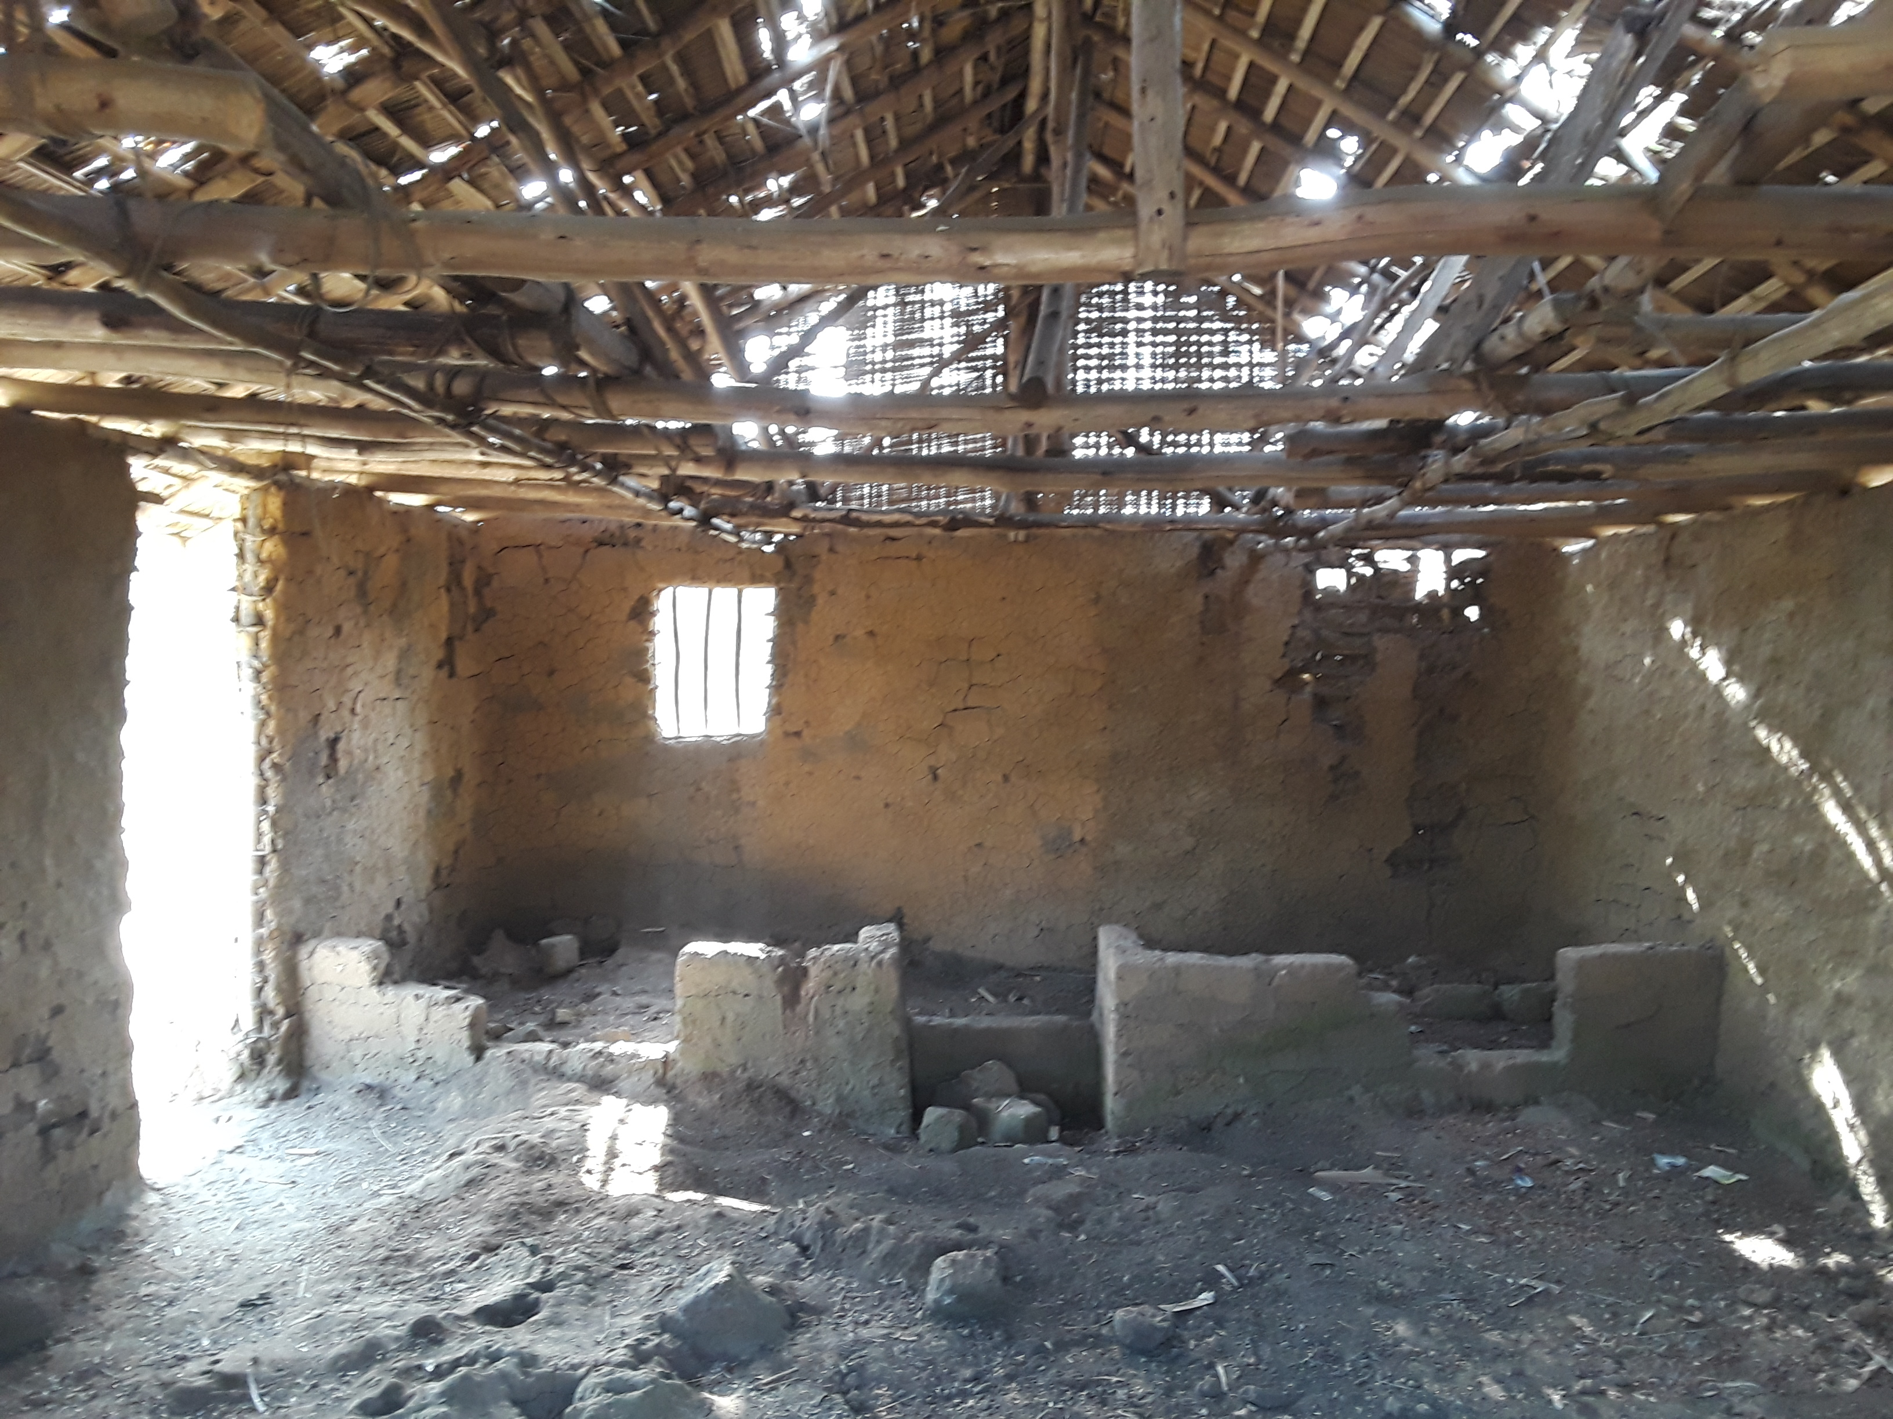
Many, if not most, of the schools and churches are in very bad physical condition. We sent 18 bundles of metal roofing upcountry to help with 6 different churches but many more need help. The costs really are quite minimal to us but are generally beyond the reach of the local people. The people are very willing to do the work but they do need our help purchasing the materials and getting them upcountry to the end of the road. From there the supplies still need to be carried to the various villages. On one recently nearly finished church the people carried over 50 bags of cement and 6 bundles of metal roofing on their heads for 7 hours, and this involved several round trips for each person. I invite individuals, churches and schools to “adopt” a school or church. This would involve funds for rehabilitation, blackboards, school supplies and the minimal teacher salaries. It would also enable those interested to travel to Liberia and work alongside the people with the renovation work and teaching. All of our schools are only up to the 8th grade and subjects are dealt with on a very basic level.

This year we continued providing kits, based on the program “Days for Girls”, to give young girls in the villages a sanitary and reusable means of dealing with their menstrual periods. Often when they first start their periods it is embarrassing and often they just drop out of school. These kits have been accepted enthusiastically by all the girls, as well as the more mature women. We are working to partner with the Days for Girls Enterprise Program to bring this health care need to Liberia. The LCL is very excited to see this program succeed and want to bring it to all their parishes.

Additionally. we are also in the initial stages of working with the “Big Belly Program” to teach expectant mothers about the changes their body is going through during pregnancy, proper nutrition, care for the baby while in the womb and afterwards. Getting the father to participate in this is another big emphasis of the program. We hope to involve the clinic staff with the execution of this program. Both of these are exciting new programs that will do much to improve the health of the communities.

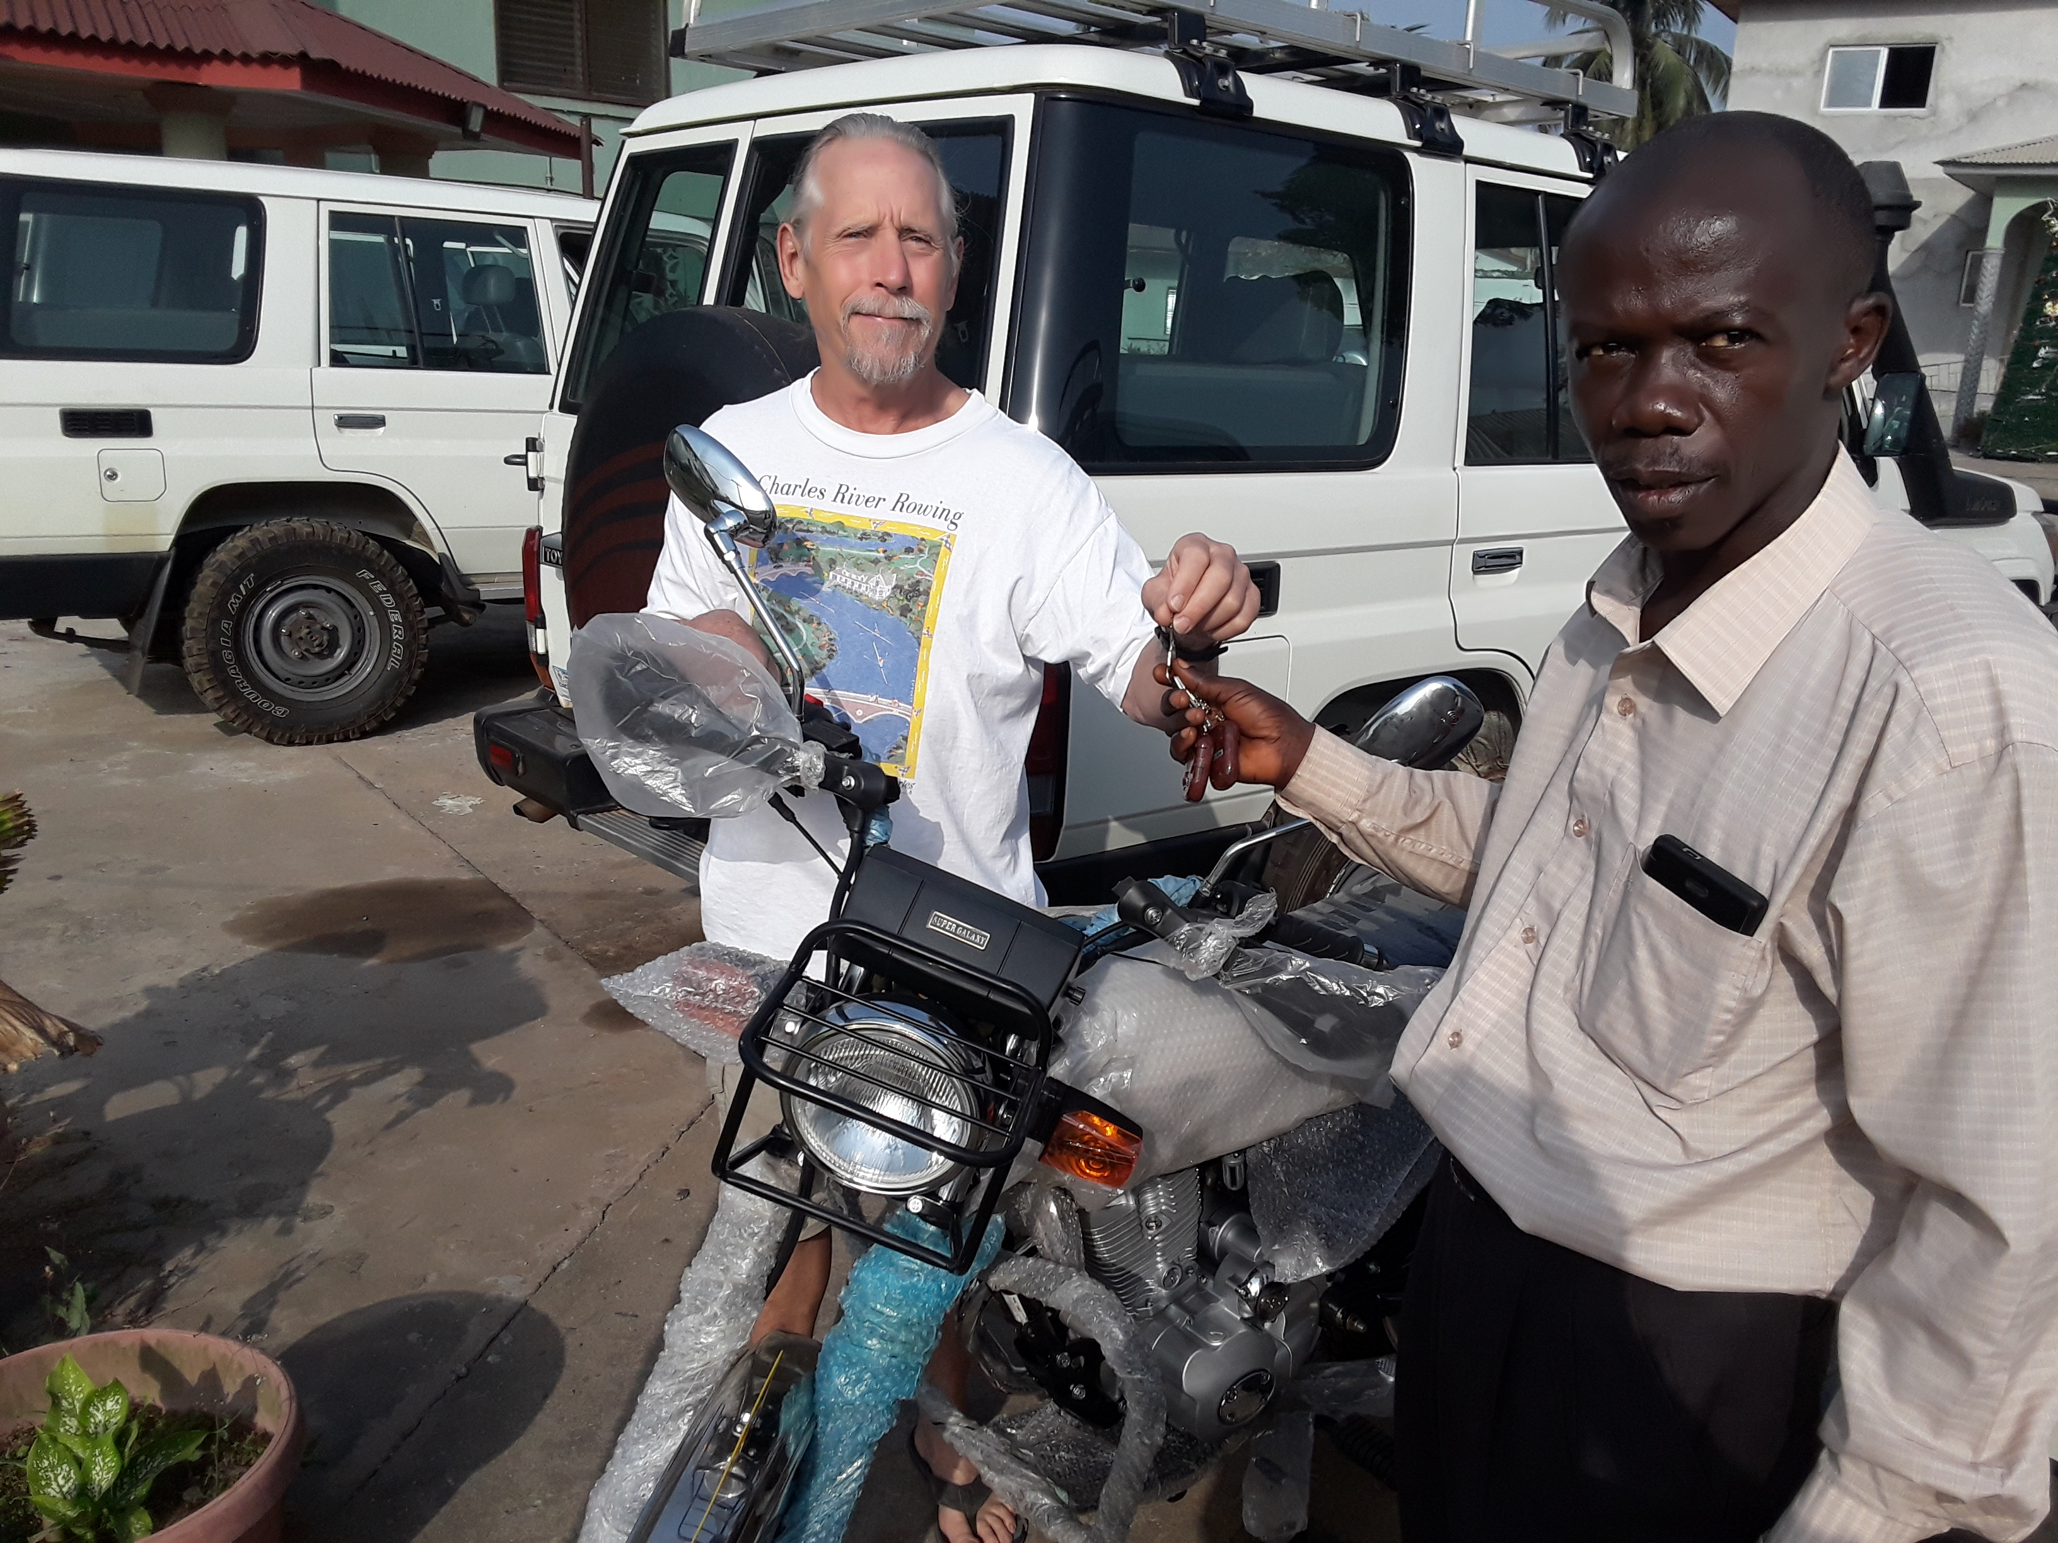
We also purchased two motorbikes. One for the use of the clinic so they can reach outlying villages for vaccination’s. The other was for the parish pastor, Rev. Paye, to enable him to reach most of his villages without having to walk for days.
Samaritan’s Purse again made available the free use of their helicopter to transfer well supplies and personnel. This saves countless hours and makes the logistical chores so much easier.

Again I want to thank you, our supporters, for your prayers and financial support. Without you we would not have accomplished what we have. I enjoyed, as always, my time upcountry walking with, eating with and visiting with the people. They are wonderful. They are supportive. They are generally humble. They need our assistance.
Please visit with your friends and congregations about adopting a school or church building. It would mean the world to the Liberians and you would gain at least as much as they will. Please contact Karen Voris our Congregational Coordinator if you are interested in this. Her email is: kvoris@kuwaamission.org.

Thank you for your continued support, Stan Olsen




Your contributions to The Kuwaa Mission are tax-deductible. We are a 501c3 non-profit organization. Our Tax ID number is 27-5458111
Donate on our Website or send a Check to the address below. Thank You!
Unsubscribe - Edit your subscription
The Kuwaa Mission: c/o Bethany Lutheran Church, 1340 8th Street, Slidell, LA 70458 www.bethanyslidell.org

