Greetings to all,

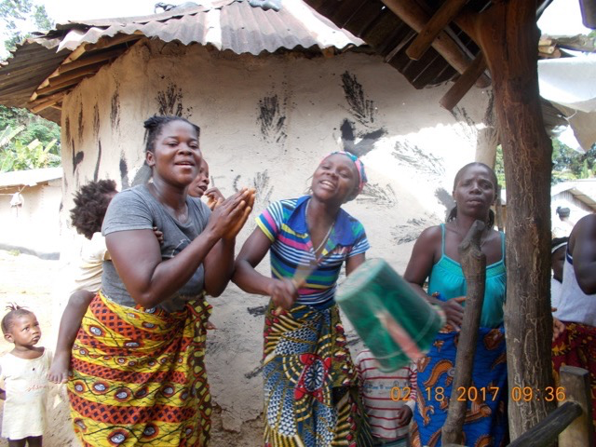
As I traveled with Cindy Ellis Bye to the villages of the Kuwaa people last February, we were greeted at each stop with incredible enthusiasm. The women and children would meet us at the edge of town and ‘dance’ us to our accommodations with such gusto; singing, playing sasas and keeping the beat with wooden spoons and water buckets the whole way. Some of the children were fearful of the bright white skin they were not accustomed to seeing, but most were fascinated with our arrival. They would sit for hours, simply watching our activities. Early on, I realized that I rarely saw these little guardians play. As a nurse, I am all about balance. They now thrive on the clean water that the village has access to, due to their partnership with the Kuwaa Mission, they have energy to just be kids.

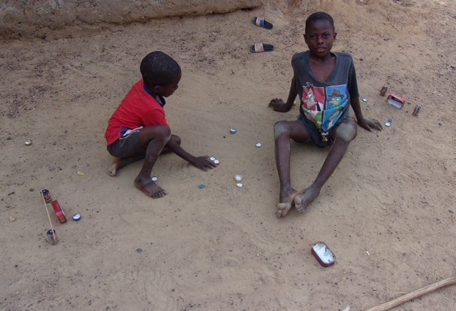
Many of you may have heard of Operation Christmas Child, I am sure some of you may have participated. It is a program sponsored by Samaritan’s Purse that gathers shoeboxes packed by volunteers around the country and distributes them to children in over 100 countries who deal with the effects of war, poverty, natural disaster, famine, and disease. These shoeboxes are lovingly filled with treasures to inspire that spirit of play, such as stuffed animals, balls and art supplies. They also include hygiene items. This may be the first gift many of these kiddos ever receive; I suspect this would be true for many of our Kuwaa kids. A note from the donor is enclosed, a sign that someone cares for them and a tangible message of hope, joy and how God’s love is shared. The most important ingredient is the prayer that accompanies the box.
The rest of the story: Although our congregation has participated in this project for several years, it was not until we met with the team in Liberia that I learned about what happens after the boxes leave our building. They are filled with the message of the Gospel in a twelve part series called The Greatest Journey. One of the first things that the Kuwaa people asked for as we met in the villages was “education”. Teachers in each area where the boxes are distributed are identified, instructed and supported in sharing these lessons. What a great education opportunity for the church leaders, as well as their young and eager students. The Operation Christmas Child team had not previously been acquainted with the Kuwaa area. These neighbors in Liberia have now been included in the distribution plan.
Many thanks for all you do for ‘our kids’ in Kuwaa!

Tara Orley, RN,
Kuwaa Mission Volunteer

Loving and powerful Father, we thank you for the precious gift of our young ones. Give us wisdom and persistence in caring for them. Guide us in doing our best loving, listening and advocating. In Your Son’s name we pray, Amen.

Your contributions to The Kuwaa Mission are tax-deductible. We are a 501c3 non-profit organization. Our Tax ID number is 27-5458111
Donations can be given in two ways:
1. Make out check to: The Kuwaa Mission (send to Bethany Lutheran Church (see below))
2. Go to the Kuwaa Mission Website at www.kuwaamission.org: use PayPal to make a one time or automatic monthly donation
Unsubscribe - Edit your subscription
The Kuwaa Mission: c/o Bethany Lutheran Church, 1340 8th Street, Slidell, LA 70458 www.bethanyslidell.org

