Greetings to all Kuwaa Mission supporters,
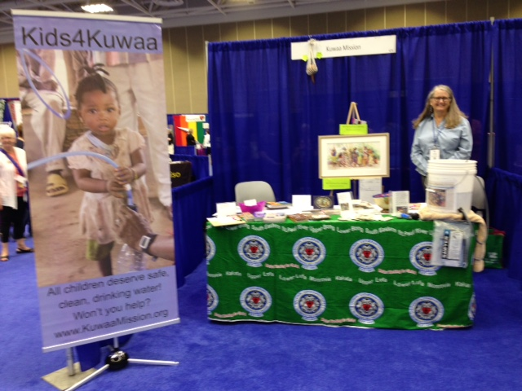
In July of this year I attended the Tenth WELCA Triennial Gathering in Minneapolis, MN. The theme was ALL ANEW from Psalm 104:30: “Lord, send forth your spirit….and renew the face of the earth.” Thousands of women from all 50 states and 12 countries were in attendance to hear motivational speakers, participate in various projects and attend seminars. There was also time to connect with many new and old friends.
The Kuwaa Mission had an informational booth that was well attended. There was a lovely picture won by Kris Mitzman of Billings, MT and a musical instrument called a sa-sa was also won.
This year the Kuwaa Mission is also branching out all anew with trainings for teachers, nurses and clergy. We are also assisting with women’s issues. This new project will provide kits for women and girls during their menstrual cycles so that they can continue to attend school and work. There are currently 7 churches, from all over the US that have expressed an interest in making these Days for Girls kits. The Lord of Life women in North Pole, AK are making the first 50 kits that will be sent out this fall.
These kits include:

- 2 pairs underwear
- 8 reusable pads
- 2 washable shields
- 1 wash cloth
- 1 bar of soap
- 1 cloth bag
- 2 qt. zip lock bags and instructions

The eventual goal is to have Days for Girls-Africa come and train and educate the women on how to make these kits themselves.
If you or your organization is interested in assisting with this project please e-mail me at kkuhnert@kuwaamission.org
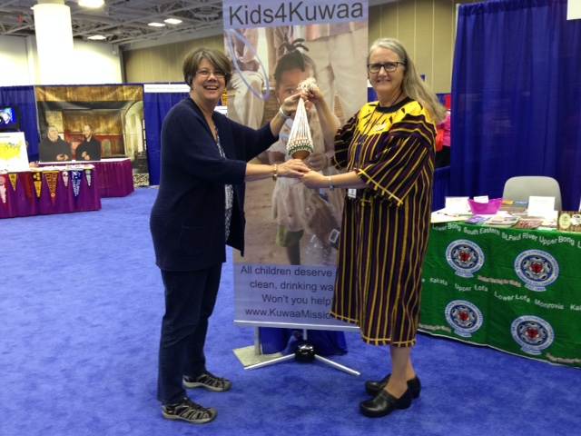
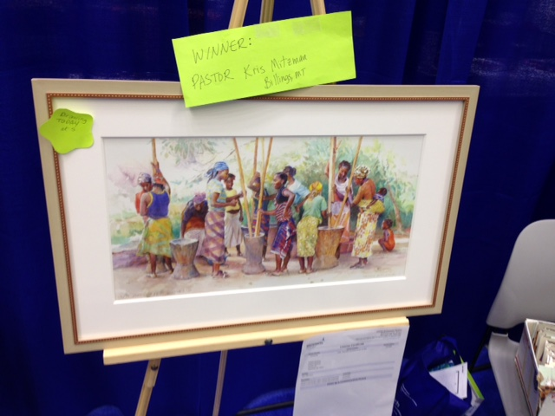
Continue to watch future newsletters for ways you can become involved and/or how your dollars are at work assisting God’s people.

Blessings,
Karen Kuhnert-Volunteer Coordinator

Your contributions to The Kuwaa Mission are tax-deductible. We are a 501c3 non-profit organization. Our Tax ID number is 27-5458111
Donations can be given in two ways:
1. Make out check to: The Kuwaa Mission (send to Bethany Lutheran Church (see below))
2. Go to the Kuwaa Mission Website at www.kuwaamission.org: use PayPal to make a one time or automatic monthly donation
Unsubscribe - Edit your subscription
The Kuwaa Mission: c/o Bethany Lutheran Church, 1340 8th Street, Slidell, LA 70458 www.bethanyslidell.org

