The evening of March 29 I left for another trip to Liberia, after a two year absence, with several objectives, as usual. Arriving in Monrovia on the afternoon of March 31st I was greeted by a friend of mine from when I was first in Liberia in 1997. It is always good to see a familiar face when one walks out of the Liberia airport into a crowd of people. Other friends greeted me upon my arrival at the Lutheran Church in Liberia’s Guesthouse, so there was no shortage of talking taking place.

My first goal was to meet with the County Health Officer, Dr. Tucker, and review the needs / wants of the Kondesu Clinic. They have many items on their wish list and some I believe we can help with but many will just have to remain the responsibility of the Ministry of Health: a steady stream of medicines, staffing needs, funding for other county health services and additional building requests. He is a very well spoken man who I believe is really working to deliver the best health care possible to this remote clinic. The clinic does see many patients, many who cover many miles on foot, to receive care. Most of these people come from the local service area but there are many who come from 2-3 days away simply because this is still the closest clinic to their village!

On April 4 I flew into Fassama with our well contractor and our bridge contractor as well as my guide, Murphy, for the next 10 days. While the trails are obvious there are no signs when one comes to a junction, I don’t speak the local language nor do I have the contacts in the villages to arrange lodging and food. Murphy is wonderful travelling companion and easily and competently looks after my needs.

We received a grant this year from Water Hope that has enabled us to install 3 new wells in Fassama in addition to the three we planned in Kalata, Sasasu and Kpaulazu. While in Kalata I discovered that there was on old well, from before the Kuwaa Mission was organized, that wasn’t working. Since we had the funds I decided that we would install a second well in Kalata this year. Thus, Kalata went from having no working well to two working wells within two months!!

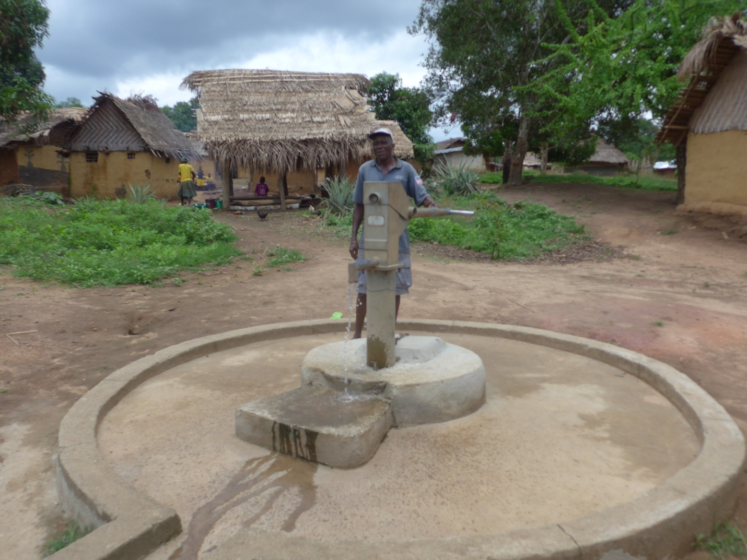
New well in Kpaulazu

It was good to see many of the villages working to build a church with mud blocks for their own use without hoping that the Kuwaa Mission would build it for them. It remains our primary focus to provide safe water, sanitation, and Christian education. However with the people demonstrating their willingness to work towards a church on their own, and with their request for “assistance” we are hoping to be able to provide roofing materials. They have the capability to do the work but the roofing materials need to be bought in Monrovia and shipped upcountry. Their willingness to take the initiative on these projects is a very welcome sign that they are starting to work towards their own development efforts.

This is the interior of the village church in Kalata

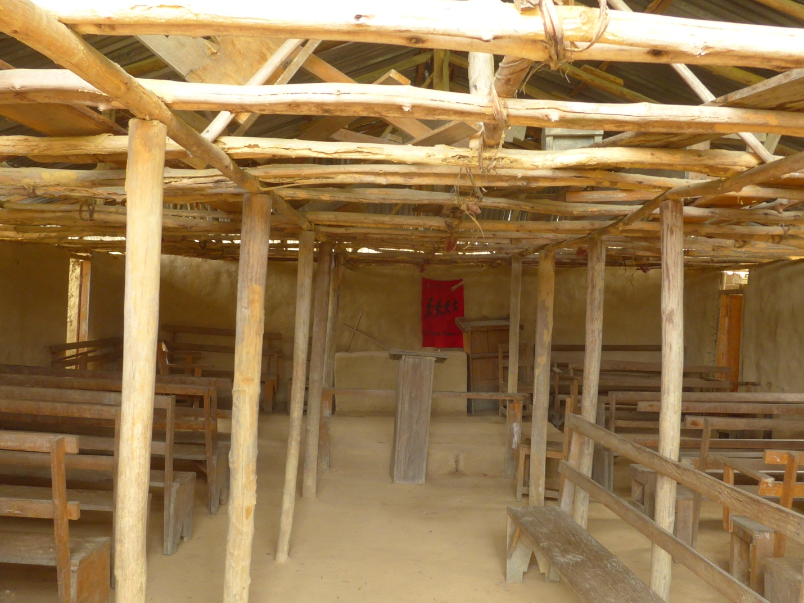
I visited our clinic in Kondesu, just by chance on April 13, to discover that it had been dedicated exactly 3 years ago to the date. It was in excellent shape, our solar system was still providing lighting and power for the refrigerators to keep the medicines stored as required. They have needs for more storage space, shelving space for supplies, a canopy over the entrance for sun and rain cover. We are hoping to be able to provide these needs next year.

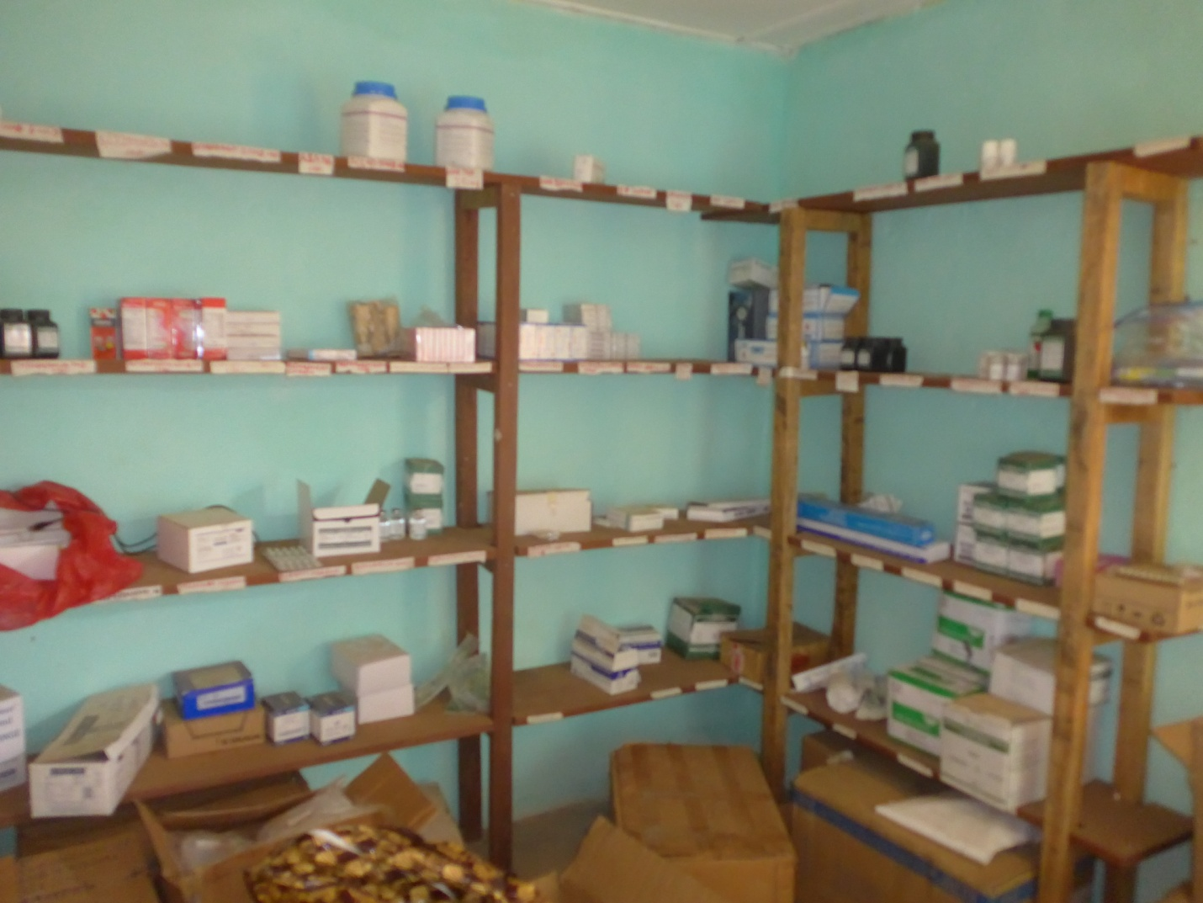
Kondesu clinic pharmacy

In Fassama I met with the District Commissioner, Jeremiah Flomo, to review our work plans and talk about their needs. The people had already done a lot of work on the main road into town from Monrovia and expended quite a sizeable amount of money for being in such a remote location. I was unable to reimburse them for their expenses but encouraged them to continue the work. I promised to take their request back to our board for discussion to see if we can help them with funding next year. They need help with fuel for the chain saw, small tools and food for the workers.

Jeremiah Flomo explained the need for the local clinic to have housing for expectant mothers and informed me of a group in Monrovia called Traditional Women United for Peace (TWUP). Upon my return to Monrovia, I arranged to meet with TWUP and had a very rewarding experience. This group was founded by an elderly lady from upcountry who realized that the women’s society needed to change and that they needed health care. She started the “Big Belly Program” to teach expectant mothers (often young girls) how their body changes during pregnancy (not to mention how they became pregnant in the first case) and how to take care of their body, provide for their nutritional needs as well as their babies. With assistance from the Carter Center they have been able to bring their program to 7 of the 15 counties in Liberia. We hope to be able to provide TWUP with travel expenses to allow them to bring their program to the Kuwaa people.

It was a wonderful trip with many positive outcomes on all fronts. It is so very rewarding to see our efforts paying off and making a difference in the lives of the Kuwaa people. There are many ways for individuals and congregations to help us with our work:
- Volunteer here in the states
- Volunteer in Liberia
- Undertake a specific fund raising project such as a well, assistance with road rehabilitation costs, various improvements to the clinic, church roofing, evangelist education, sponsoring a sanitation workshop, sponsoring a Children’s Bible School program and many others.
Please contact I, or Karen Voris, our congregational coordinator and we will be happy to work with you.

Thank you all again for your prayers and financial support over the past 10 years. With you and God’s help all is indeed possible.

Stan Olsen
CEO, Kuwaa Mission

Your contributions to The Kuwaa Mission are tax-deductible. We are a 501c3 non-profit organization. Our Tax ID number is 27-5458111
Donations can be given in two ways:
1. Make out check to: The Kuwaa Mission (send to Bethany Lutheran Church (see below))
2. Go to the Kuwaa Mission Website at www.kuwaamission.org: use PayPal to make a one time or automatic monthly donation
Unsubscribe - Edit your subscription
The Kuwaa Mission: c/o Bethany Lutheran Church, 1340 8th Street, Slidell, LA 70458 www.bethanyslidell.org

