Tara Orley, a nurse from Anchorage, and I recently returned from a trip to Liberia. It was a fruitful trip, and I was happy to have a buddy along. We covered a lot of territory, mostly on foot. We visited 9 of the 16 Kuwaa villages over a period of about 2 weeks. There will be info on the website and facebook, with lots of photos. I can’t cover it all here.
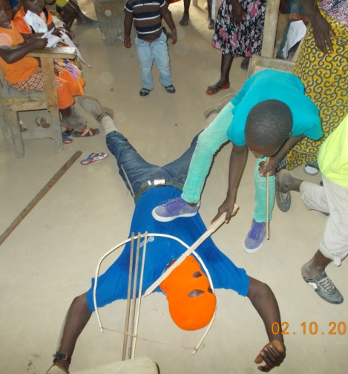
We did another Children’s Bible School this year, since it has been so popular in the past. There were 158 children in attendance for 2 afternoons as lessons were taught about David and Goliath and about Jesus’ love for children. They memorized Bible verses, sang songs, had snacks, and received school supplies. The popcorn snack and crayons were a new experience for most of them; they had never seen them before. We also brought pencils and the essential sharpeners, so that they will quit using razor blades to sharpen pencils.

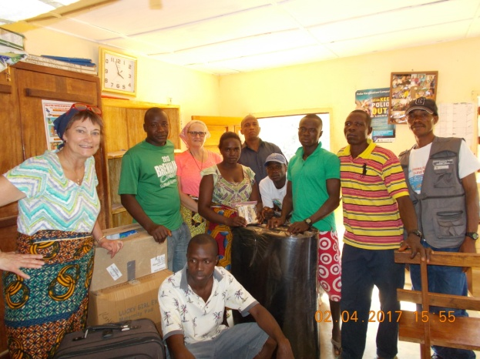
Tara did workshops at the Fassama and Kondesu Clinics, and several general sanitation workshops. She brought much needed supplies to the clinics. We are so thankful to Providence Hospital of Anchorage for the donations! The Kuwaa people are overjoyed about the new clinic at Kondesu. They are fully staffed and helping 30 to 40 patients per week. Although the Liberia Ministry of Health has taken over general operation of the clinic, the Kuwaa Mission helps with additional supplies and transportation. We really appreciate the sacrifice that the nurse, head midwife, and other clinic staff are making to serve in such a remote area. Many of their families live elsewhere.

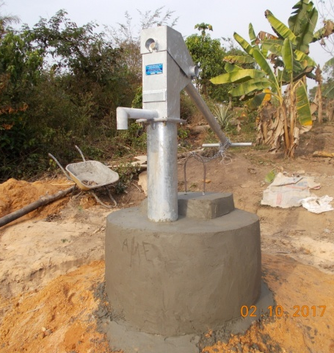
New water wells are being dug, and one was completed in Kalata while we were there. Kalata is a village of more than 1000 people, and they previously only had one well to serve everyone. Of course, that is not enough, so they are now blessed to have 2 wells. The water from these wells is clean enough to drink. The people are also trained in how to maintain the wells and pumps at a hands-on workshop.

In Monrovia, we were invited to a lunch that Bishop Jensen and the church leaders gave for several volunteers from various organizations around the world. They expressed their thanks to us for coming, and we talked about the various projects we were doing. The Bishop said that we don’t really have to do much more than show up. We don’t have to work hard. Just the fact that we are willing to travel the long distance and live in the uncomfortable conditions that are a daily reality for Liberians, shows that we love them. We suffer from the heat and lack of electricity, and deal with the many frustrations and challenges that are all too common to Liberians. The Liberian people know that we come because we love them. We are all God’s children, and our presence is an indication of the love we have for them.
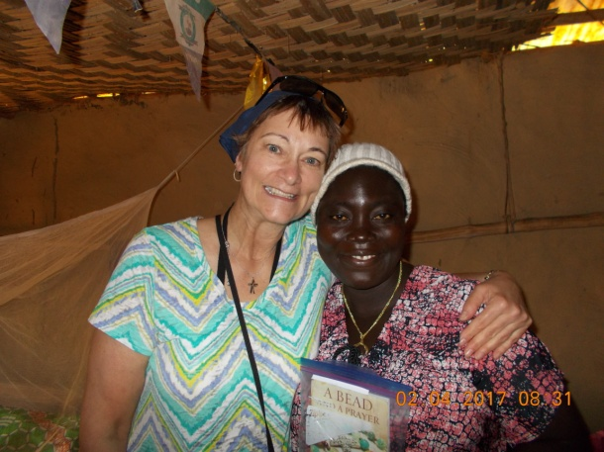
The Liberian people also return that love to us in many ways. They are so welcoming. When Tara and I arrived, people came from across town to welcome us. One good friend brought gifts of watermelon, cucumbers, oranges, a papaya, and pineapple. That’s a special treat when you come from the cold winter weather of Alaska and Montana. They all made sure we were fed and well cared for, with things like water for the bath, rice and soup, and a place to sleep. They do all that they can to keep us healthy and safe.

I am thankful that I was able to make another trip to the welcoming and loving Kuwaa People. Our projects are going well, and the Mission is doing great things, thanks to all of you for your prayers and financial support. I also want to thank all of you for your prayers for those of us that travel to Liberia. They mean a lot to us.

Please join me in prayer:

Loving and gracious God,

We thank you for the rich and welcoming spirit of the Liberian people. We know that you are with them through the trials of their daily lives. Keep them close to our hearts, oh Lord, and help us to learn from their deep and sustaining faith. We ask for safety and good health for the workers digging wells and doing the other projects of the Kuwaa Mission. We ask for peace in the country, as they have national elections this year. Guide and protect us all, and help us remember that we are all brothers and sisters in You.

Amen.

Cindy Bye

