Happy New Year! As we look forward to 2017 we ask for your continued support and prayers as our work continues in Liberia.
Romans 12:4-5
"For as in one body we have many members, and all the members do not have the same function, so we, who are many, are one body in Christ, and individually we are members one of another."
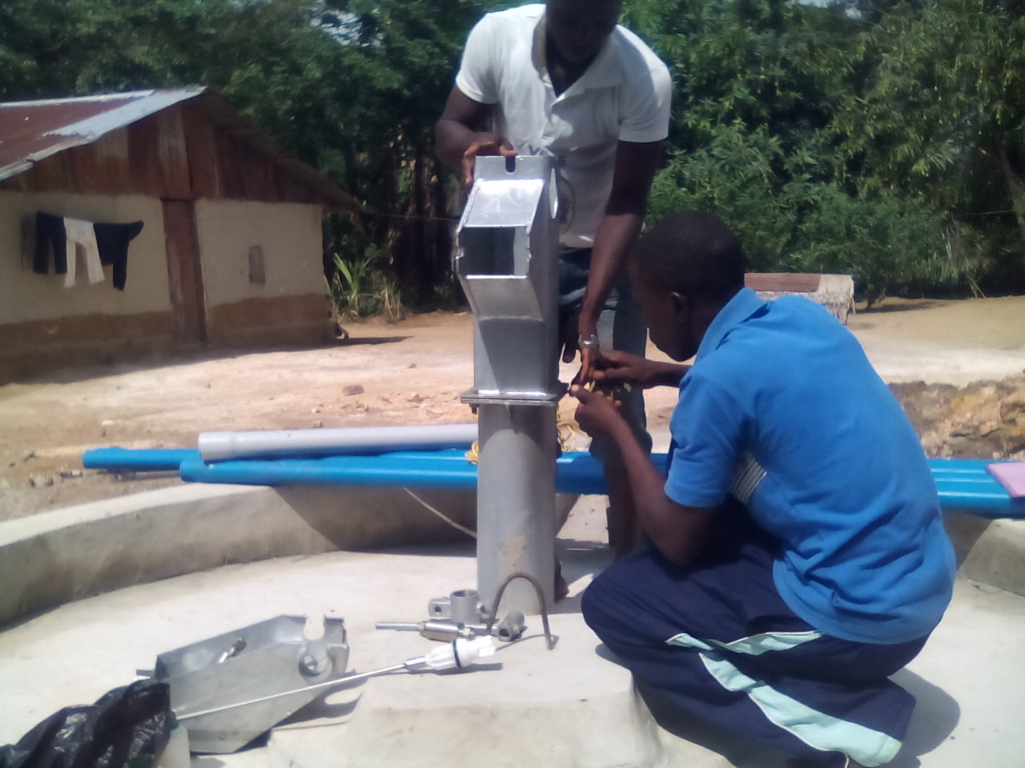
We have our most ambitious work program yet planned for this year. We will be installing 6 new wells and doing repairs on 3 other wells. We are installing 3 wells in Fassama, the largest city in the area, as a result of a grant we received from Water Hope. We will also install one well in each of the villages of Kalata, Sasasu and Kpaulazu.

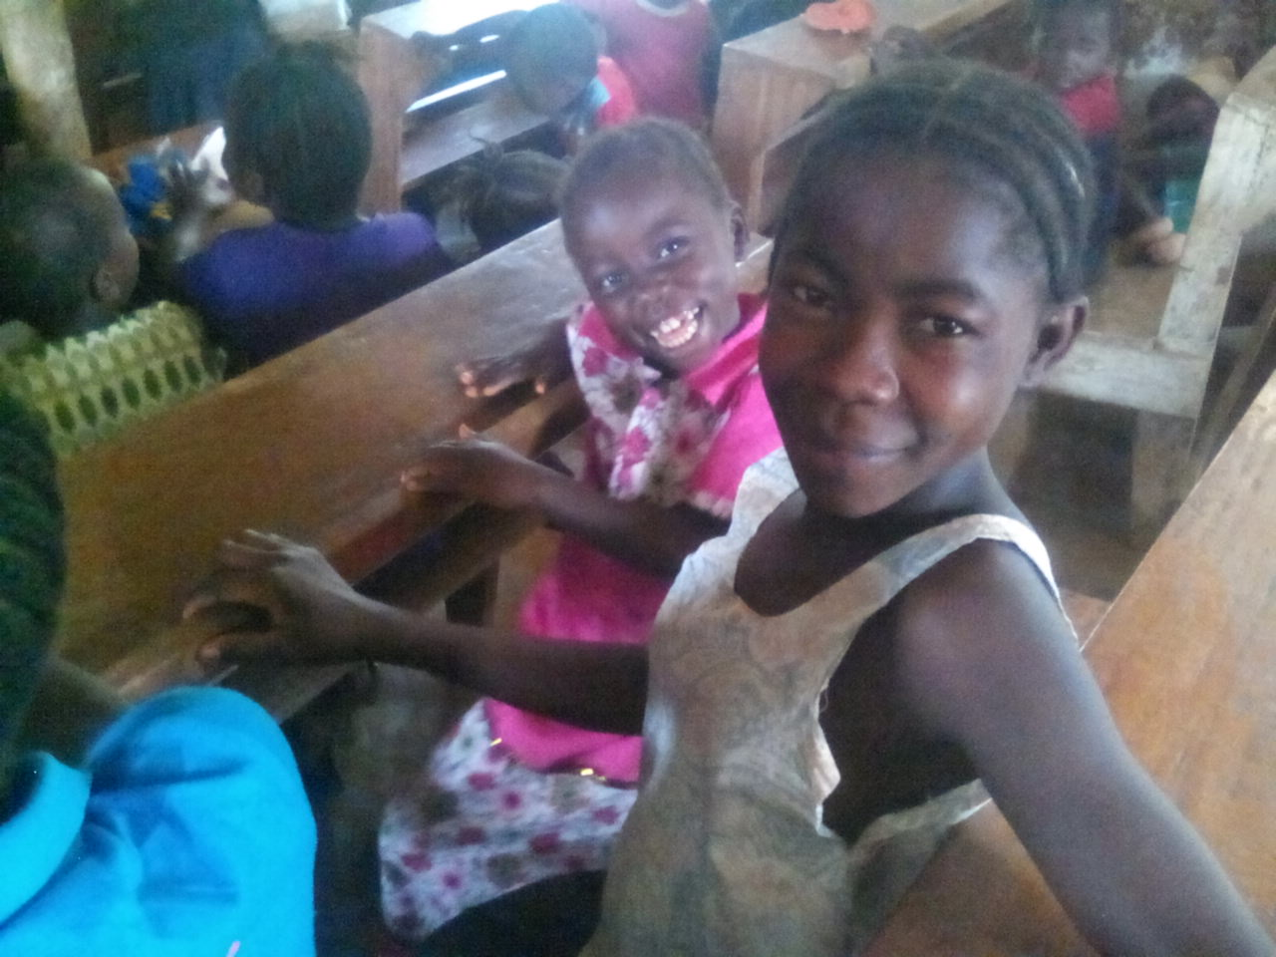
In addition to installing and repairing these wells we will be holding a week long workshop to teach youth, men and women, in the village how to maintain their new well. It's a simple process but one that they need training in, and that the village elders need to buy into to actually allow these trainees to perform the simple maintenance on the wells.

We are also very excited to be holding a Children's Bible School (CBS): It will be held in Kalata and we are expecting around 200 children to attend. The lessons will be from the Old Testament probably David & Goliath, or Daniel. This program is very popular with children and adults alike.

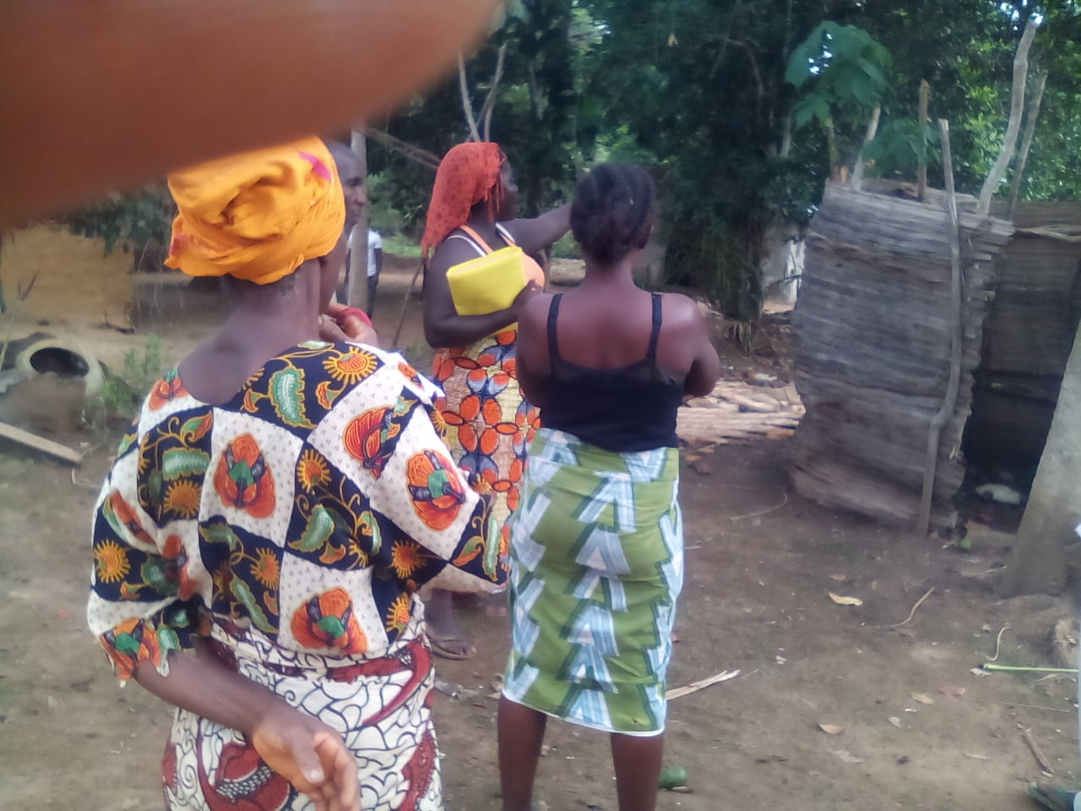
Based on the UNICEF program "Community Led Total Sanitation" we will be conducting several one day sanitation workshops led by our Liberian facilitator in several of the villages. The goal is to visit the positive as well as negative sanitation practices in the village. Ultimately we hope the women, who are the main movers and shakers for getting things done, will realize why they should not have feces, both human and animal, spread widely around the village. Secondly, to get them to realize that the people in the village can take steps on their own to control this problem, mainly by building outhouses. We provide them with a pick and shovel. A couple months later our facilitator will return to check on their progress. Hopefully as more villages participate the lessons will be transferred by women from one village to another without our assistance.

Finally, in an attempt to keep the news of our mission in front of our supporters we are developing a congregational representative contact program. Please consider becoming the representative for your congregation. Please contact Karen Voris at kvoris@kuwaamission.org for more information.

As we embrace 2017 we give thanks for your involvement in our mission.

Your sister in Christ,

Karen Voris

The Kuwaa Mission is a 501c3 charity, your donations are fully tax deductible and don’t forget to ask your employer about matching donations. Our Tax ID number is 27-5458111

