The Kuwaa Mission would like to thank our many supporters – individuals, couples, families and congregations for your prayers and financial contributions. We would like to take this opportunity to suggest other ways you can assist the Kuwaa Mission and the Kuwaa people.

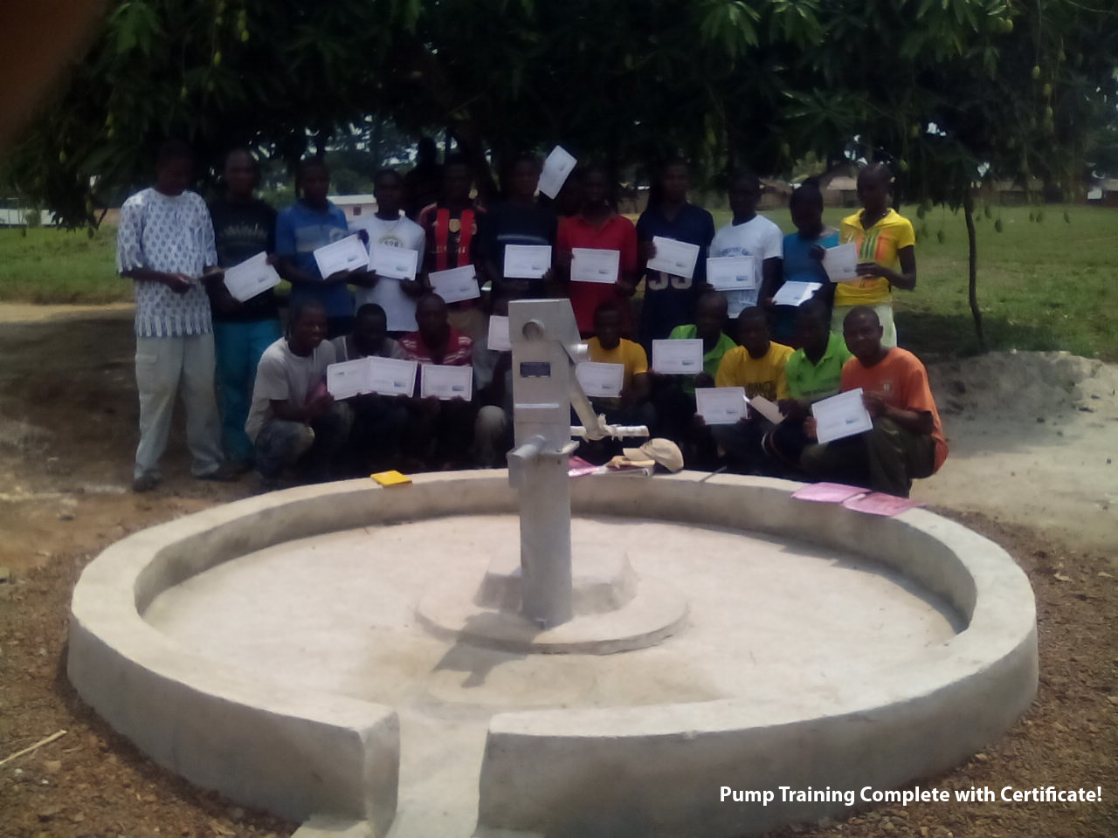
We are so grateful for the efforts of those who represent the Kuwaa Mission to their congregations. Congregational representatives tell the story of the Kuwaa Mission to their fellow members and encourage special offerings and events to raise money for specific projects such as a well or children’s bible school. If you would like to help us with this, please contact our board member Karen Voris at Karen.Voris@kuwaamission.org As a congregational representative, you could inform your members of these other ways to help:

If you have insurance through Thrivent, you can help the Kuwaa people by choosing the Kuwaa Mission for their Thrivent Choice dollars program. Thrivent has provided over 300 million dollars to charities since 2010. Go to this website: https://www.thrivent.com/making-a-difference/living-generously/thrivent-choice/ and choose the “Kuwaa Mission” to help us receive these funds through Thrivent.

Another opportunity to assist the Kuwaa Mission is every time you do your online shopping with Amazon. For eligible purchases, the Kuwaa Mission receives .05% of your payment. You order through smile.amazon.com – same products and prices - but we get a small portion as a donation from Amazon. For more information, and to register the Kuwaa Mission as your charity, please go to this website: https://smile.amazon.com/gp/aw/ch/about

Our “Kondesu Clinic” that we constructed two years ago is fully functional and supported by the Liberian Ministry of Health. Due to funding problems from the national ministry, as is typical of all Liberian Ministries from the national government, the clinic does not receive supplies and medicines as frequently as needed. Please help us buy supplies and medicines in Liberia to take to the clinic please mark your gift “Clinic Supplies”. Our website: http://www.kuwaamission.org/donate/has all the information as to where to send your support.

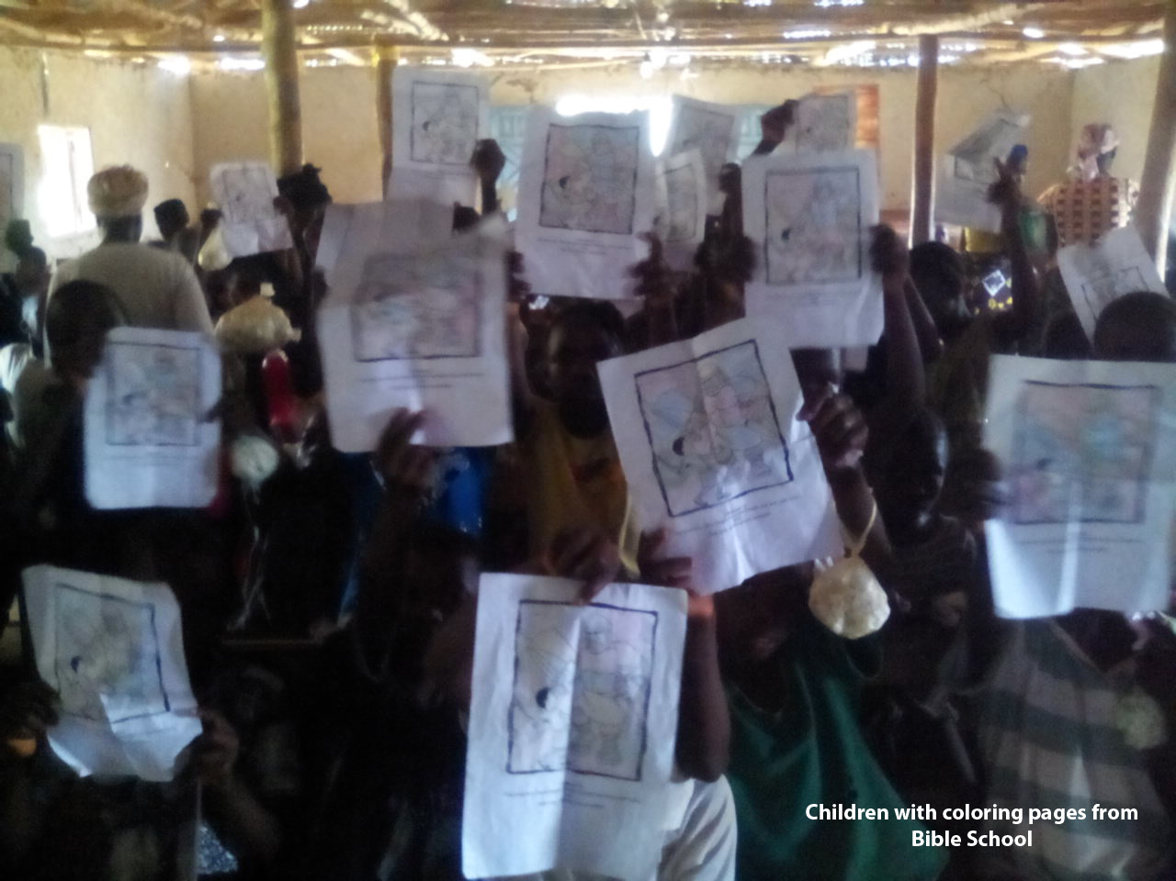
We covet your prayers! Please pray for the Kuwaa Mission - that our work with the Kuwaa people continues in Liberia with safe travel and sufficient travel funding. Please pray for healing for Rev. Richard Thompson, a founding member of the Kuwaa Mission. Please pray for the Kuwaa people and all the citizens of Liberia that they continue to be free of Ebola and that they receive increased resources for clean water and medical care. Please pray that the Living Water, Jesus Christ, is accepted into their lives and hearts.
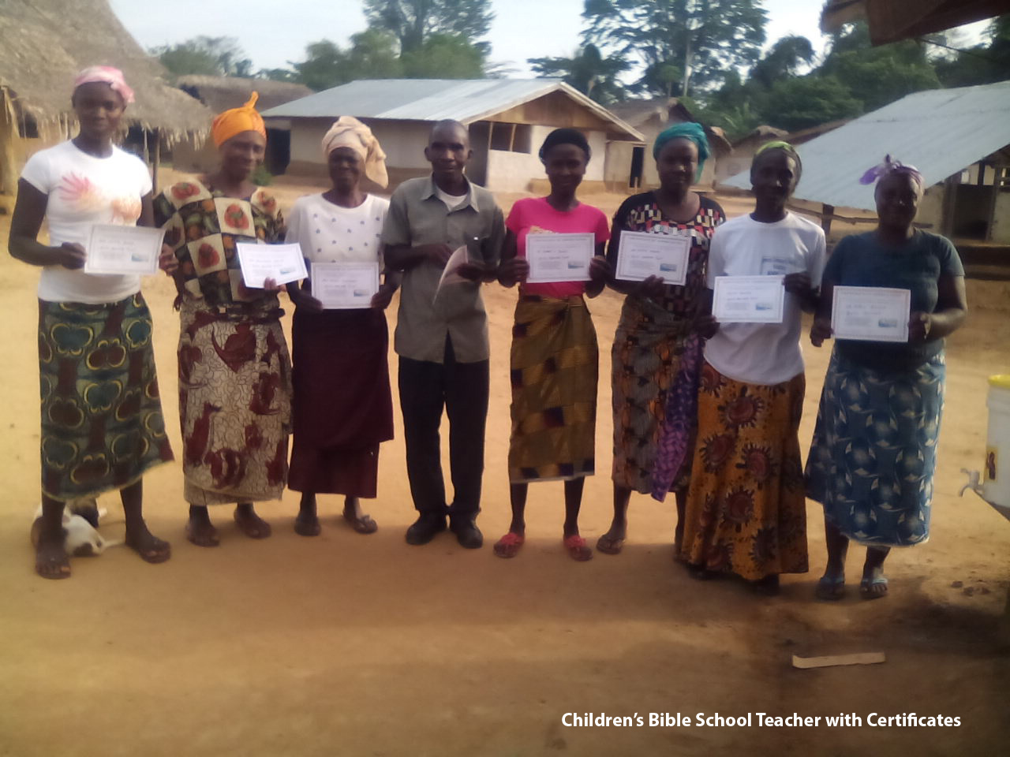

We thank God for you – for your heartfelt prayers and generous support.

Jenny Cosgrove for the Kuwaa Mission

The Kuwaa Mission is a 501c3 charity, your donations are fully tax deductible and don’t forget to ask your employer about matching donations. Our Tax ID number is 27-5458111

