THE KUWAA MISSION - KIDS4KUWAA PROJECT

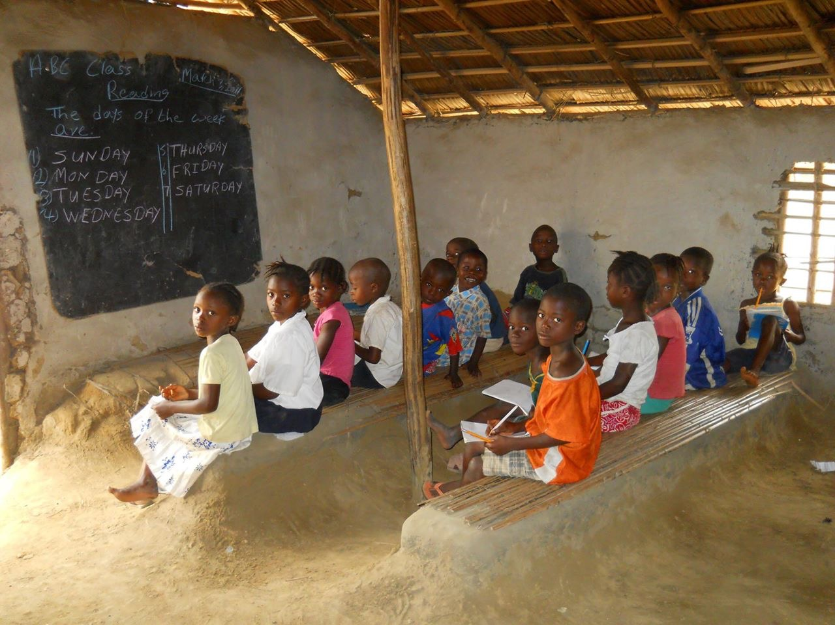
Fall will soon be upon us and many Sunday Schools and Christian Schools will be selecting some of the missions that they will pray for and support this coming school year. If you are looking for a children’s mission project, Kids4Kuwaa in Liberia would be an excellent choice to consider and pray about. They need our prayers and support.

Consider that half the children in Liberia die before they reach the age of 10. Many die due to childhood and tropical diseases along with malnutrition. Children must pay to go to school and they must have uniforms or they cannot attend. They need school supplies. Their desks are often just wooden planks. Kuwaa children live in remote villages. Only a very few are on the motor road so there is limited schooling and even more limited medical facilities and help.

These factors are currently being addressed by the Kuwaa Mission. We and our supporters have built a clinic in Kondesu which is staffed by a nurse that attended nursing school with our scholarship help. We currently have helped to build and repair bridges that allow for easier transportation by motor bike or by foot to the farthest villages. We are currently seeking information from the Dept of Education in Liberia so that we can assist the teachers to get better training with workshops we can provide.

Kids4Kuwaa was the idea of a young Lutheran girl in Alaska who had a heart for these very children. She collected “noisy” offerings in her church services in little tin pails. Since then the Kuwaa Mission has promoted Kids4Kuwaa within Sunday Schools and Christian Schools.The Liberian children deserve to live longer, be healthy, and a quality education. They are the future leaders of the Lutheran church and Liberia.

To assist you with this project, we have a children’s Liberian Coloring book for you to photocopy and colorful bookmarks for the children. Please contact us if you would like to have any or both of these items for your mission project this coming school year.

Diane Stelling- Kuwaa Mission Board Member
dstelling@kuwaamission.org

The Kuwaa Mission is a 501c3 charity, your donations are fully tax deductible and don’t forget to ask your employer about matching donations. Our Tax ID number is 27-5458111

