As the summer draws to a close we at the Kuwaa Mission hope that you had an enjoyable summer and were able to spend some quality family time and enjoy God’s great outdoors.

The Board of the Kuwaa Mission greatly appreciates all the support that we have received over the past year. July marked the beginning of a new fiscal year for us and as a result of matching funds from employers we start this year on a very sound fiscal footing. As you consider your financial gifts to the Kuwaa Mission please check with your employer to see if they have matching funds program. We are a 501c3 organization with the IRS and can provide you, or your employer, with any information required. This program makes a huge difference in the amount of work we are able to do to serve the Kuwaa people.

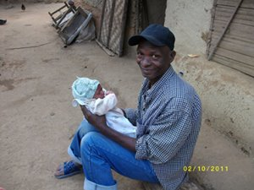
I also ask each of you to consider being a “Mission Member” in your congregation. As a “Mission Member” we ask you to carry the Kuwaa Mission program directly and frequently to your congregation by speaking about the work we have accomplished, our financial needs, and the programming we have planned for upcoming seasons. We will provide you with brochures, videos, fundraising ideas and all the prayer support one could ask for. We do receive good congregational support from congregations across the US but we need to increase this support base. While we realize that much of our individual support comes through the local congregation we also have a line item in our budget for “congregational support” and we are looking to increase our financial support here as well. As a “Mission Member” we also ask you to visit other congregations in your geographical area and spread the word about the Kuwaa Mission. There are many congregations that have a mission program, or would like to start one, and just need a bit of direction. Every new congregation that supports our work is a valuable member of our team. Please contact our congregational coordinator: Karen Voris at kvoris@kuwaamission.org and we will work with you to serve the Kuwaa people.

Many, if not most, of you receiving this newsletter use “Facebook”. Please consider passing on the work of the Kuwaa Mission to your “friends”. The Kuwaa Mission website receives many “hits” and the more “hits” we receive the more support we will receive, both financial and prayer support.

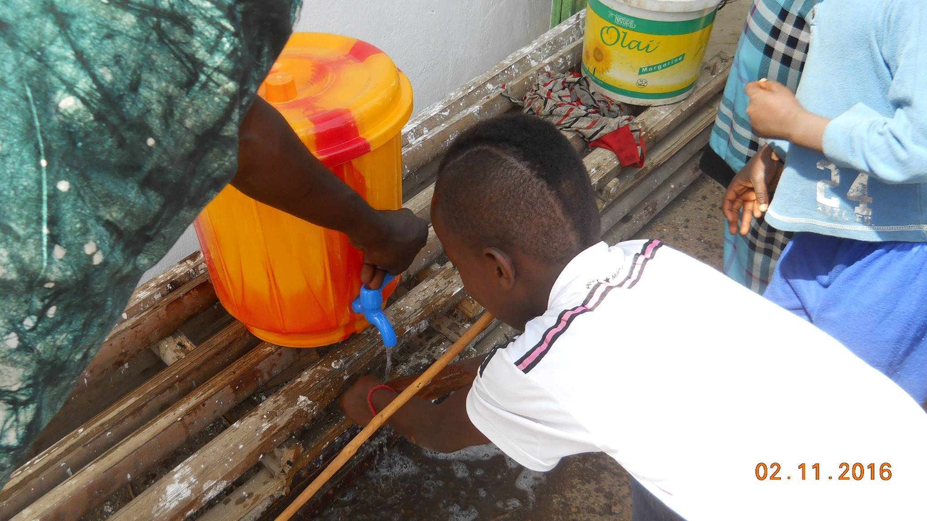
This coming work season in Liberia I will be travelling into the Kuwaa area with the Bishop of the Lutheran Church in Liberia, Rev. Dr. Daniel Jensen Seyenkulo, and meeting with the Kuwaa tribal leaders and the local commissioner to thank them for the support we have been given and to work with them to increase the support base with the people. Rev. Seyenkulo is one of the founders of the Kuwaa Mission and it is through our excellent relationship with the Lutheran Church in Liberia (LCL) that we have been able to reach out to so many Liberians. Bishop Seyenkulo thanked me today for all the support we have been able to provide to the Kuwaa people working with and through the LCL. It is because of people like you that we have accomplished so much.

Thank you again for your support and please contact Karen Voris for additional information on how you can become a “Mission Member”.

Stan Olsen
CEO Kuwaa Mission

The Kuwaa Mission is a 501c3 charity, your donations are fully tax deductible and don’t forget to ask your employer about matching donations. Our Tax ID number is 27-5458111

