Merry Christmas from the Kuwaa Mission

On behalf of the Kuwaa people of Liberia, West Africa, we wish you all a most Blessed Merry Christmas 2015 and Happy New Year 2016.

The Kuwaa Christians celebrate Christmas much as we do. They observe Advent in their churches and many of their houses will have simple Christmas decorations. The women will dress up in their finest Lappa garments. The children learn Christmas carols in school along with the Christmas story. There will be church services on Christmas Eve and Christmas Day. Often they will have a community feast on Christmas Day, sharing the food as we do with our church pot lucks.

Thank you so much for your continued prayers and financial support of the Kuwaa Mission as we share the Word made flesh, Jesus Christ, with our Kuwaa brothers and sisters in Christ. In 2016 we will be doing the following: digging a new well, conducting VBS classes, offering sanitation training, assisting local evangelists, supplying medications for the recently completed medical clinic in Kondesu, and building a number of bridges sorely needed for the access to the clinic and access between the villages. Please keep our busy 2016 work program in your thoughts and prayers throughout the year. We will be providing you with frequent up-dates as the work progresses.

Yours in Christ for the Kuwaa,

Ed and Diane Stelling

Missionaries to the Kuwaa with Lutheran Bible Translators, 1973-1979.
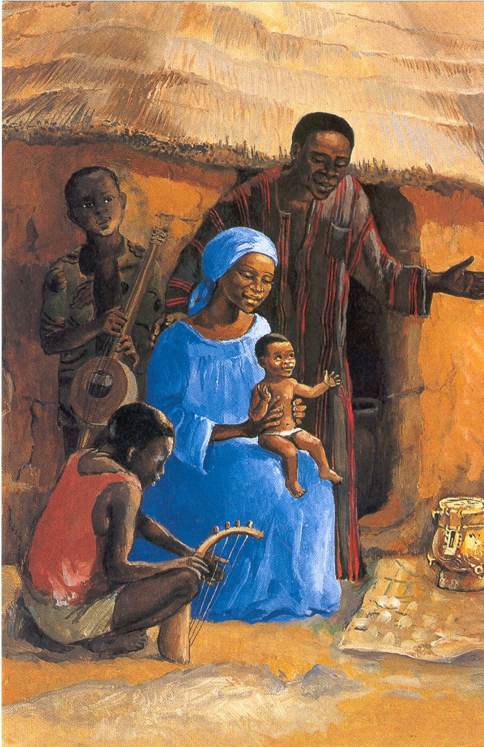

Note: your contributions to The Kuwaa Mission are tax-deductible.
We are a 501c3 non-profit organization.

