ROADS AND BRIDGES!!

Matt. 25:34-36 “Then the King will say to those on his right. ‘Come, you who are blessed by my Father; take your inheritance, the kingdom prepared for you since the creation of the world. ³⁵ For I was hungry and you gave me something to eat, I was thirsty and you gave me something to drink, I was a stranger and you invited me in, ³⁶ I needed clothes and you clothed me, I was sick and you looked after me, I was in prison and you came to visit me.’

We are so excited and grateful that Cindy Bye can return to Liberia in January, 2016. Due to the Ebola crisis, we were unable to return to Liberia in 2015. By God’s grace, the Ebola crisis is over and the Kuwaa chiefdom was relatively untouched!! Thank you so much for your prayers for Liberia and the Kuwaa people during that difficult time.
Liberia, and particularly the Kuwaa chiefdom, is in a tropical rainforest – emphasis on RAIN!! Liberia receives between 80 and 200 inches of rain a year (Monrovia is the wettest capital city in the world). How does that affect the work of the Kuwaa Mission? American volunteers come to Liberia only during the dry season (mid-November through March) because the roads are impassable at other times of the year. When we arrive, the roads and bridges have been washed out or damaged due to the heavy rainfall during rainy season. This makes for delays and difficulties in bringing important supplies to the villages.
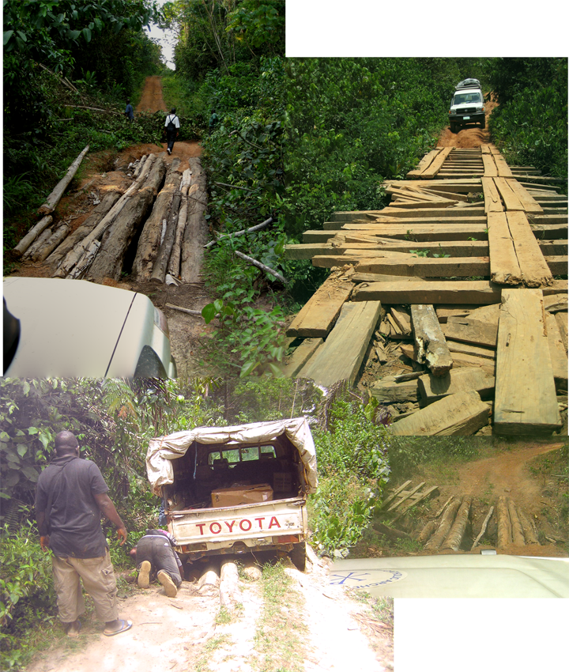
Right now, Liberian colleagues are busy working on bridges and roads. We have sent funds for the needed supplies and labor to clear roads and repair bridges so that they are ready when Cindy Bye comes in January to provide children’s Bible school, hygiene and sanitation training, and medical supplies and support. If we receive enough donations, we can also renew work on wells. Without good roads, the trucks laden with bags of cement and other supplies cannot reach the villages. Other modes of transportation must be found which are much more expensive. These roads are not just for Cindy’s comfort (although they will be appreciated!), they are necessary for the economic and physical well-being of the Kuwaa people. Without clear and passable roads year round, the Kuwaa people have difficulty accessing the medical clinic. With good roads and bridges, the villagers can engage more easily in commerce which supports the local economy.
Will you partner with us to provide the funds for this important work? Your donations go far in providing life-enhancing and even life-saving clean water, public hygiene, and medical support. Even more important, the Kuwaa Mission loves to tell the story of the Son of God who provides living water. Please pray for the Kuwaa people that they may know Jesus as their Savior.
Among the Kuwaa people, it is customary to say “Na Mama O-Oh” (thank you) when you see someone working. We wish to say “Na Mama O-Oh” to you for the work you do for the Kuwaa Mission and for God’s Kingdom. Thank you.
Sincerely,
Jenny Cosgrove

Note: your contributions to The Kuwaa Mission are tax-deductible. We are a 501c3 non-profit organization.

