2015 Thanksgiving Prayer Letter

‘Tis the season to be thankful…
Dear friends of the Kuwaa Mission,
Always be joyful. Never stop praying. Be thankful in all circumstances, for this is God’s will for you who belong to Christ Jesus. 1 Thessalonians 5:16

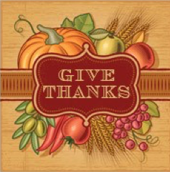
As Thanksgiving approaches this year it is time once again to pause and give thanks for the many blessings we’ve been given. Even as we are aware of war, violence, injustice and suffering in many places around the world, we are also aware of the many ways we see God’ hand of healing at work. In the midst of crises, God’s people reach out with hope, offering tangible acts of service and gifts of grace.
One of the places this is surely evident is in the work of the Kuwaa Mission. From the dedication of our volunteers to the faithfulness of our donors and partners we have seen God’s hands at work to bring hope, healing and Good News to the people of the Kuwaa villages during 2015.
We wish to offer a particular word of thanks to the staff and volunteers of Samaritan’s Purse who have been willing and available to deliver equipment, provide much needed transportation services for our Mission volunteers, and distribute aid during the Ebola crisis. We deeply appreciate their partnership with us and all that they do in our and surrounding regions of Liberia and around the globe. May God grant you continued success in your ministry!
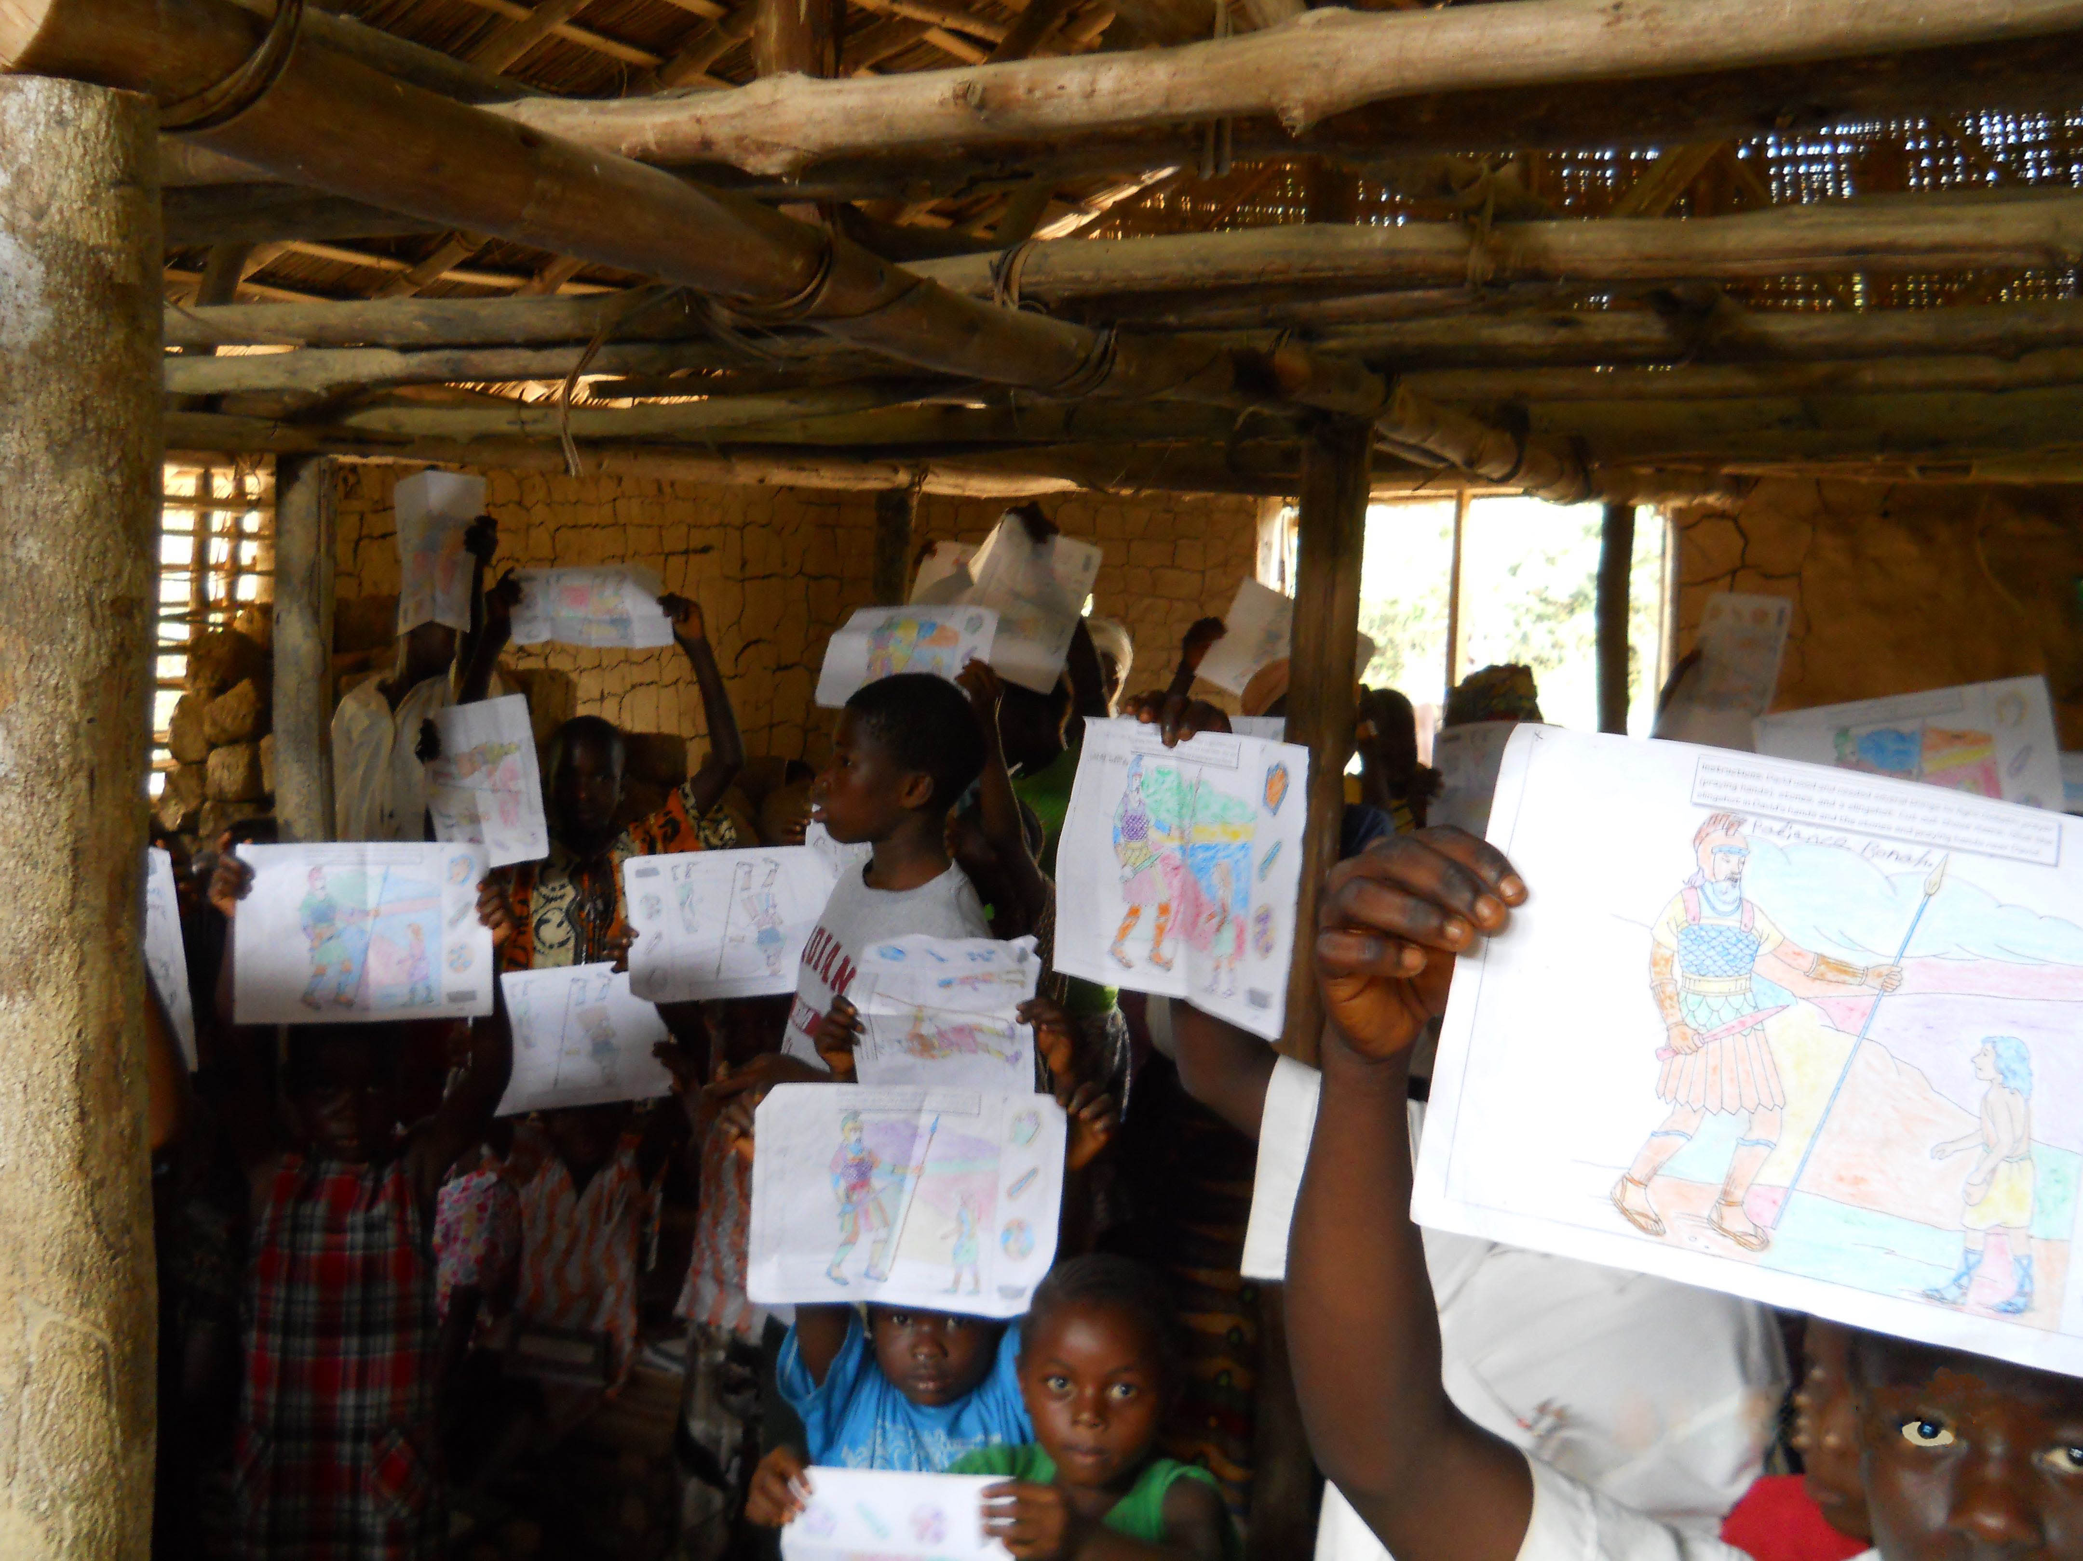
Thank you, too, to our volunteer missionaries, CEO Stan Olsen and former Board Chair Cindy Ellis Bye, who leave the comforts of home to travel to our partner villages delivering hope and encouragement along with their love of Jesus and the Kuwaa people, and their expertise in construction and engineering, furthering the work of the mission in so many ways.
We also wish to thank YOU, our many generous donors, who support the work of the Kuwaa Mission through your monthly pledges, Noisy Offerings, special events and promotions, and your prayers. Your gifts in 2015 made it possible for us to provide training and materials for Children’s Bible school for over 240 children, to train 21 people from 5 different villages in how to maintain and service well pumps, provide a sanitation training in Belle Baloma, to install two new wells in Belle Baloma and Teiglei, purchase medicines for the Kuwaa medical clinics and, with the help of Samaritan’s Purse, the Lutheran Church in Liberia, and the Evangelical Lutheran Church of Liberia, provide relief to families suffering from Ebola during the recent crisis.
We still have much to do. In 2016 our focus will be on building bridges to make it possible for villagers to receive medical attention, supplies and food year-round. This is a big undertaking and we are asking for your continued financial and prayer support.
We always pray for you, and we give thanks to God, the Father of our Lord Jesus Christ. Colossians 1:3
May God bless each of you and your families this Thanksgiving and all year through.

Rev. Carol George, Chair
Kuwaa Mission Board of Directors

Note: your contributions to The Kuwaa Mission are tax-deductible. We are a 501c3 non-profit organization.

