As summer begins to ebb away, ebbing quickly here in Alaska!, we are busy preparing for another season of activity for and with the Kuwaa People. Liberia has essentially recovered from the Ebola crisis so we are looking forward to another dry season of productive programs.

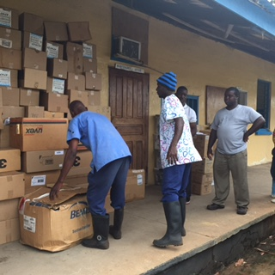
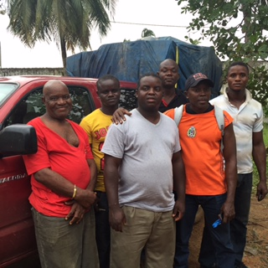
The Ministry of Health is now staffing the clinic that we finished almost two years ago. In addition to birthing, the mid-wives have a basic understanding of the health care needs of the people and how to see that they get the medical help that is available. Dr. Harris, the shorter man in the white tee shirt, is the son of a former bishop of the Lutheran Church in Liberia. He recently travelled to Liberia and made available to the Kuwaa Mission a pickup load of medical supplies for the clinic. Due to the condition of the roads at this time of year we were not able to transport them directly to the clinic. We put a notice on the radio and many people came on a 2-day walk from their villages to get the medicines and walked two days back to the clinic. We praise God for making this possible and the people for their dedication.

Our well contractor is now conducting an assessment of three villages to see exactly what the well needs are. After this season we will have installed either new wells or refurbished wells in all of the 16 villages. Some have more than one well but all have working wells delivering potable water for the first time since the very early 1990’s and some for the first time ever!!

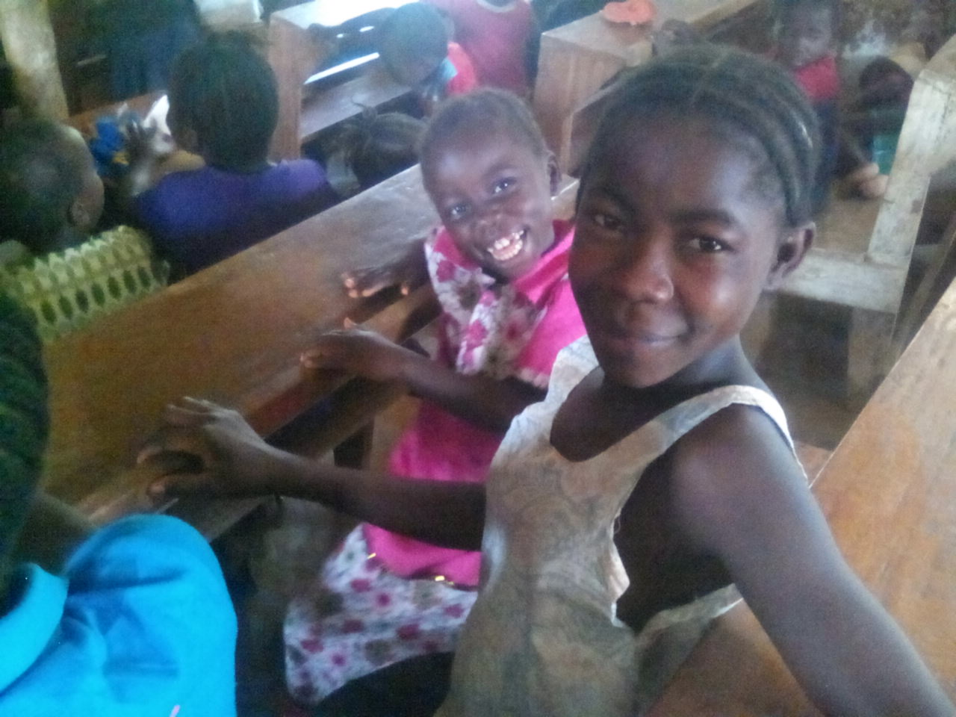
We again will be conducting a sanitation workshop with the women from one of the villages. This has been very successful in teaching them to understand the basic principles of sanitation and why the feces around the village needs to cleaned up and latrines built. They willingly undertake this responsibility.

Children’s Bible School is a program that has grown beyond our wildest expectations from around 100 the first year to well over 200 last year. 200 is stretching it to be a manageable number but the program will continue for however many children show up.

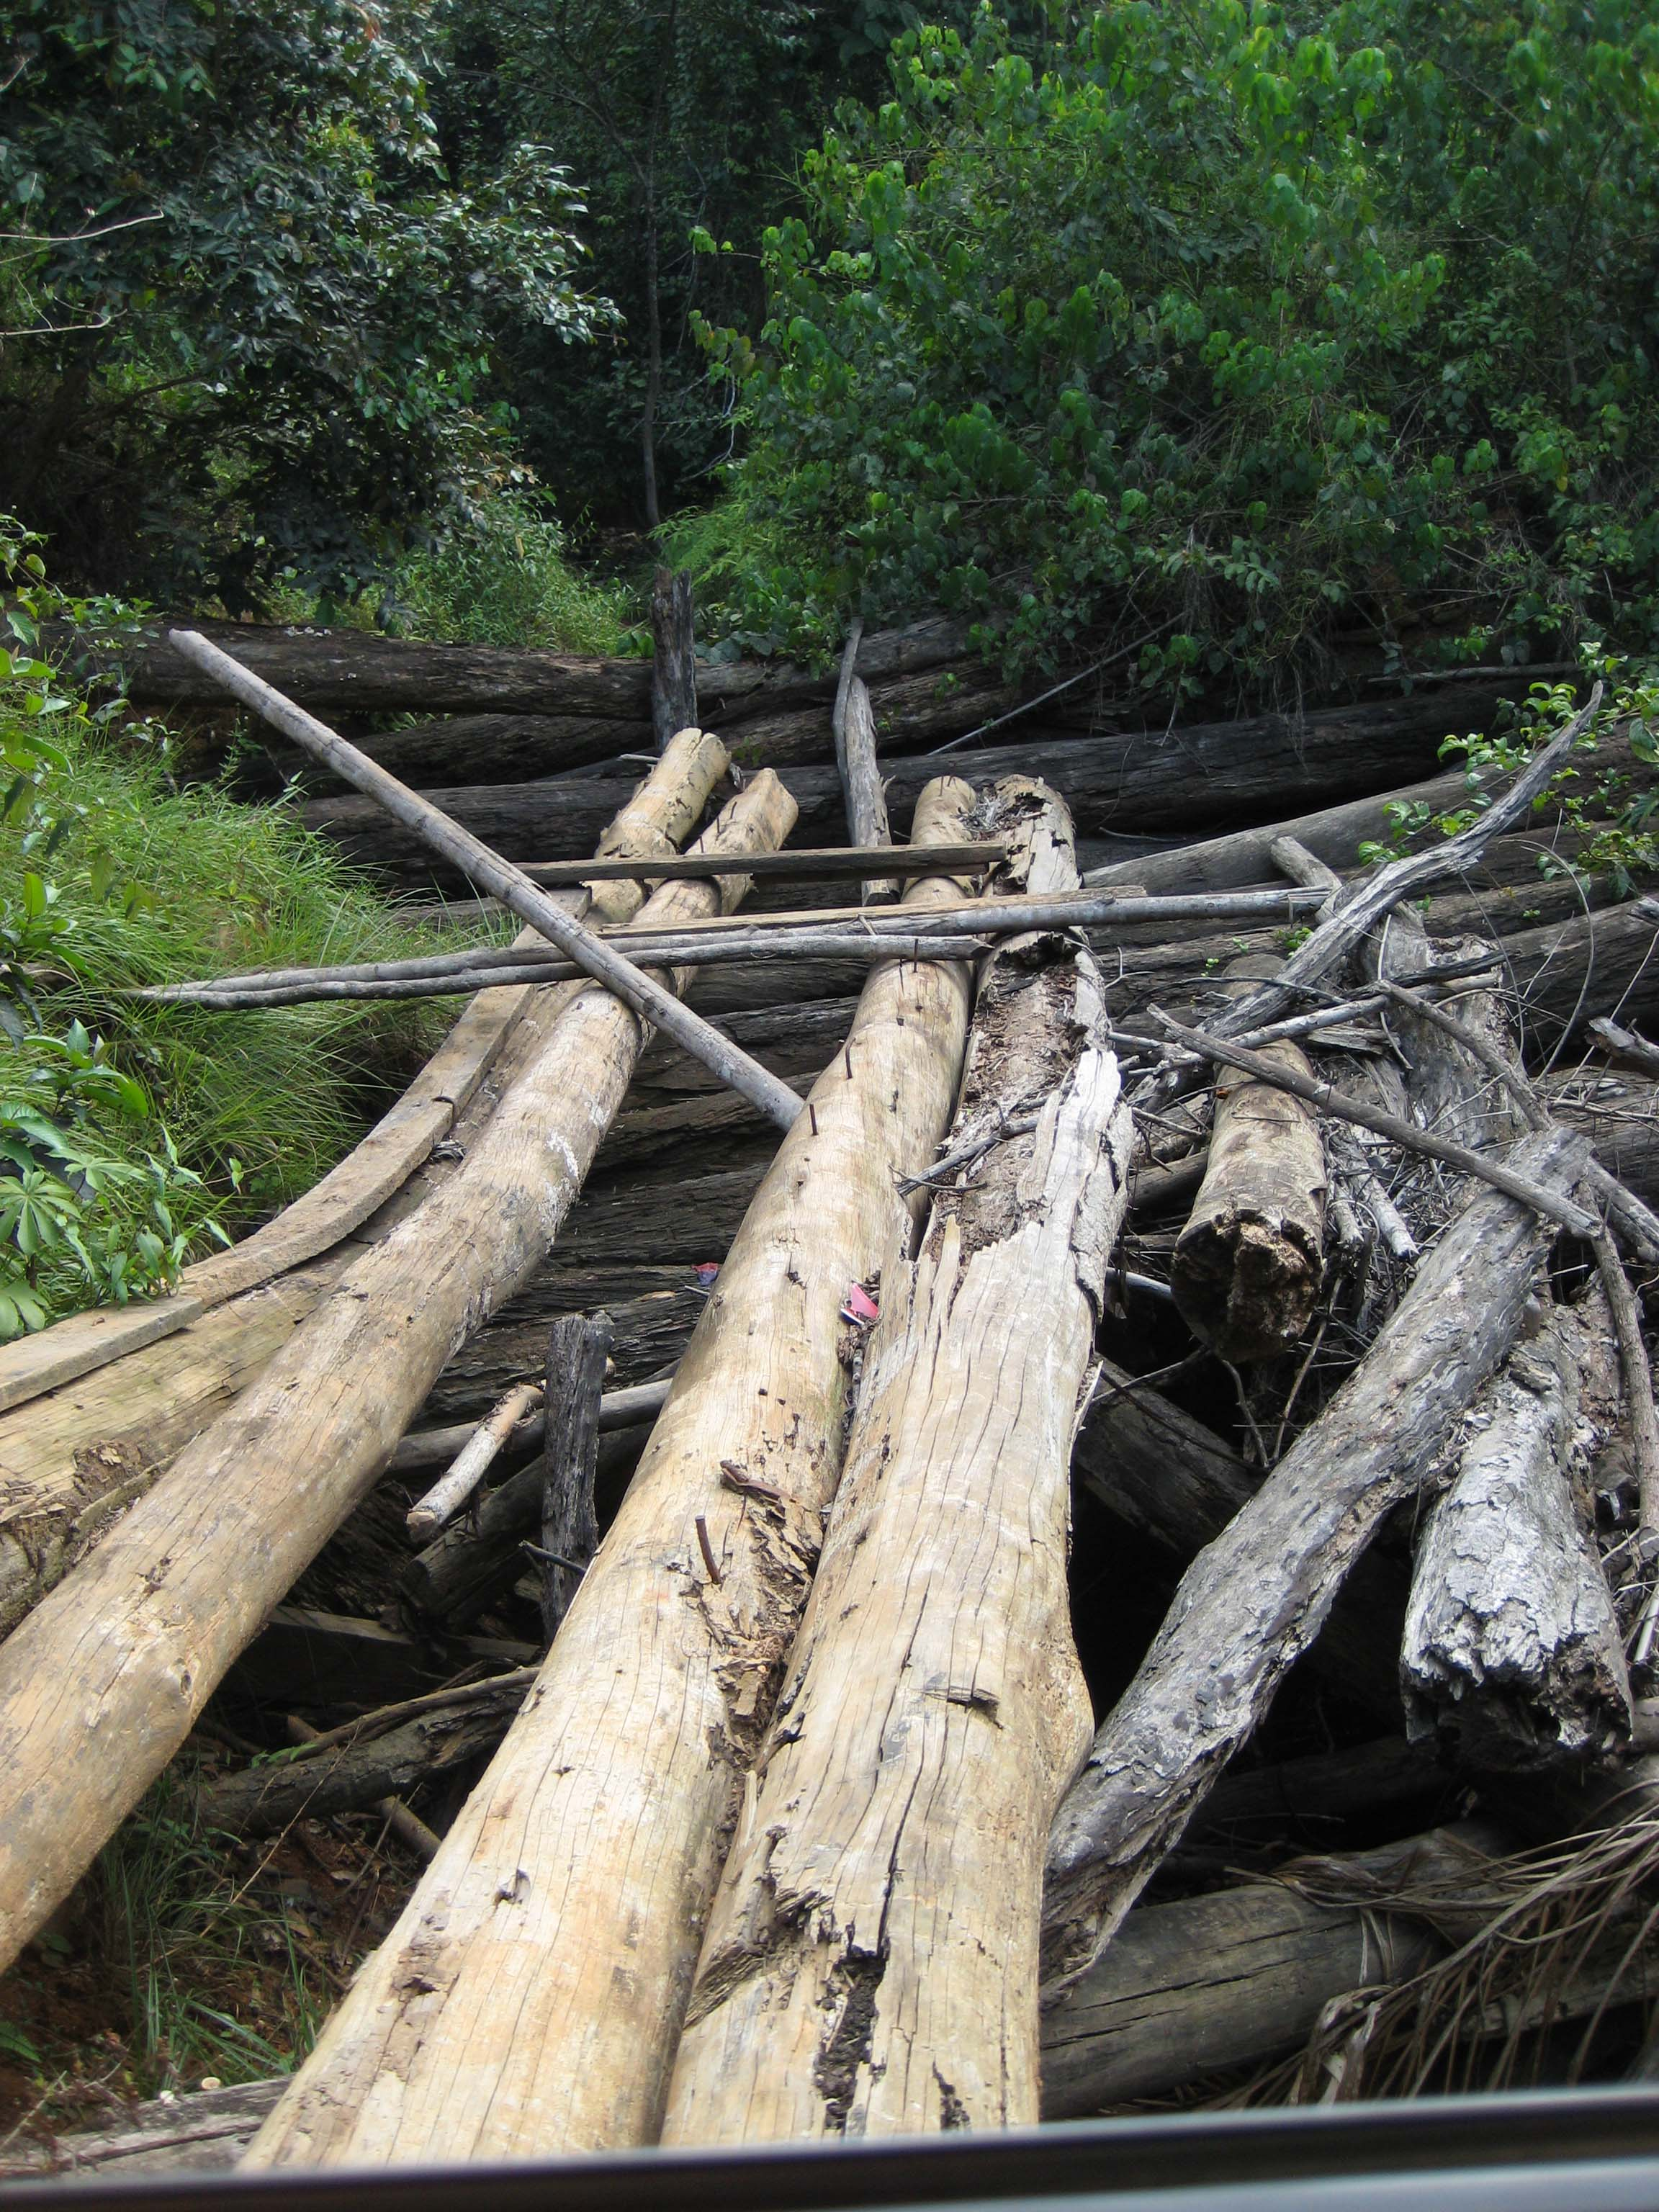
As Ed Stelling mentioned last month, we are undertaking a new program this year: building bridges. The feeder road from the clinic to the main road has many bridges that are only passable by motorbike. Two of the bridges have fallen down completely and any traffic is rerouted down into the creek bed. We have a signed contract with a man who will rebuild the main bridges as well as install small log crossings over the smaller creeks. All constructed in order that a pickup truck can safely pass. Our clinic contractor will oversee this work. Upon completion the Ministry of Health will be able to access the clinic easily and the people will have a means to get their produce to market much more efficiently. Health care and economic development all in one program!!

As our new board takes over the reins of the program we thank all of you for your prayers and financial support. We ask your continued prayers for the Mission and that we will raise the funds to complete the planned work projects this years. We are so so close and need your continued support.

Thank you and God bless.
Stan Olsen
CEO

