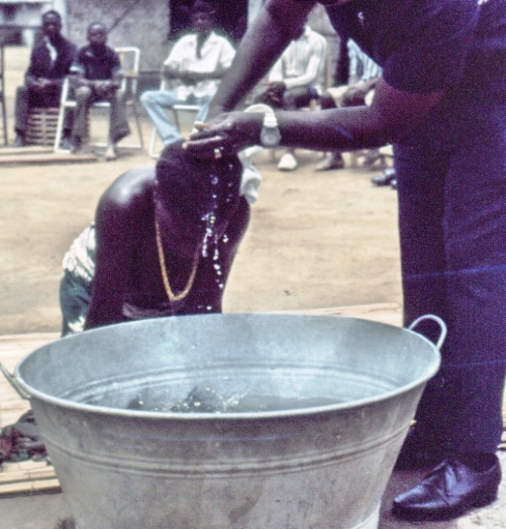
40 years ago, May 1975, 105 Kuwaa people were baptized into Christ Jesus in Konjade where the Rev. Richard Thompson & family lived and worked as missionaries. The Christ movement started there and spread to other Kuwaa towns. Peace and joy reigned, but in 1989 that came to an end. The Kuwaa people suffered under the various rebel groups during the 14 years of civil war. Their homes and villages were destroyed. Their farms burnt and looted. In 2009 the Kuwaa Mission came into existence to help the Kuwaa people find peace and joy again. The mission planned to focus on helping the people help themselves. The goal is to help them rebuild the infrastructures of the villages. The first priority of the Mission was to help the villages dig their own wells. Too many children were dying because of bad water. The Mission also helped build a medical clinic in Kondesu. The clinic will help the people of several towns. The mission held workshops to train the people about the advantage of drinking and using good water and how to care for the wells and filters. Workshops were also held to train teachers, and they were held to train church leaders about teaching children and adults Bible stories and religious material.

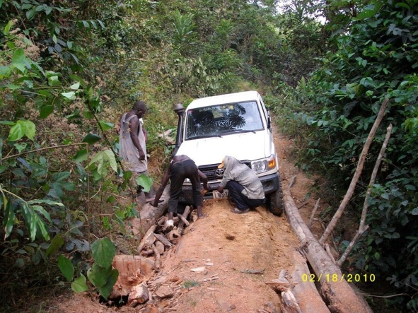
Plans to start building and rebuilding bridges and roads are now underway. It won’t be cheap but desperately needed. Better roads will definitely help the Kuwaa people. One of our volunteers has donated $6,000 for this project if the Mission matches his funds. The Board of Directors is asking you to pray about this need. The more funds received by the Mission means more roads and better bridges.
The work will be much easier and cheaper if a road system is developed in the chiefdom. More villages can be reached and helped.
I must give a big “Thank You” to all of you who are praying for the Mission and the Kuwaa people and to all of you who are supporting the work program. The work cannot go on without your help. I also want to give a special “Thank You” to all of you who have volunteered to help the Mission here or in Liberia. The last “Thank You” goes to the Board of Directors who have maintained the work of the Mission without much help from me this last year. Keep up the good work.

Current and Ongoing Work

• Building and Repairing Roads
• Providing Wells
• Providing Water Filters
• Providing School, Student & Medical Supplies
• Build and repair Churches and Schools
• Providing Bibles and Teaching Materials
• Providing Training Workshops (Bible, sanitation, medicine, etc.)
• Providing Scholarships
• Liaising with Government & Non-Profit Organizations
• Finding and Sending Volunteers
• promoting the work of the Mission

God has blessed your work.

Your brother in Christ’s love,
Rev. Dr. Richard Thompson, co-founder of the Kuwaa Mission

Please visit our Website and our Facebook page for pictures of the work that your donations support!
Please designate your checks: The Kuwaa Mission and mail to the following address:

