Help celebrate The Kuwaa Missions 5th Anniversary
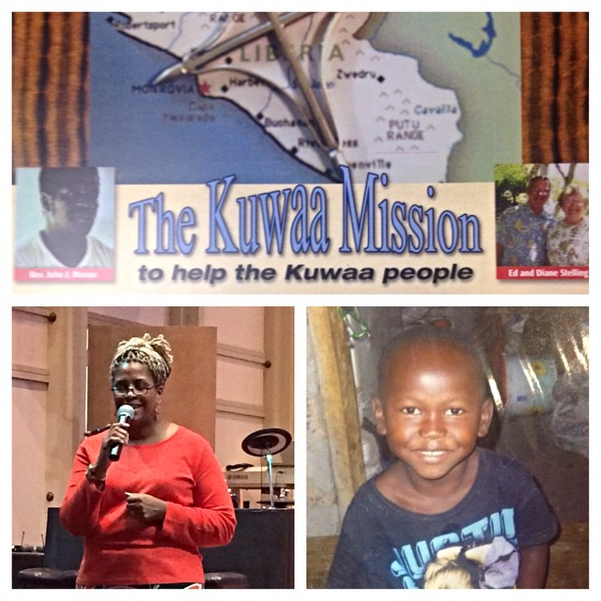
Pray, Volunteer, Donate or Partner
With God all things are possible Matt 19: 4
During this Holiday season please join the Kuwaa Mission Board as we celebrate five years of God's work.
On November 9th 2014 Board member Lolitha Shepard celebrated with Bethany Lutheran Church in Slidell Louisiana, the birthplace of the Kuwaa Mission.
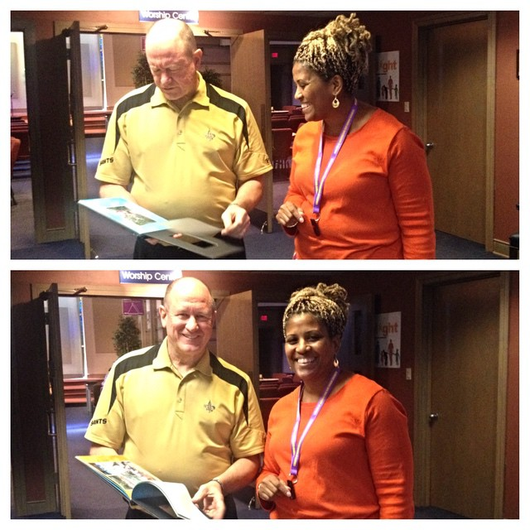
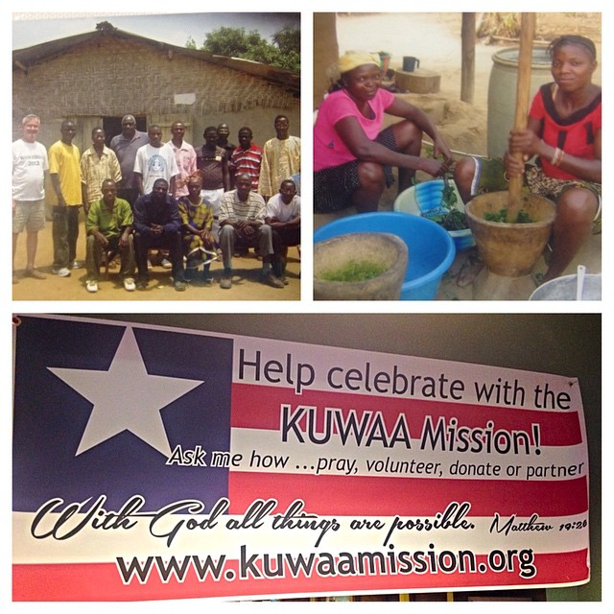
The members were moved to see how God is transforming the lives of the Kuwaa people in far away West Africa. This transformation was supported by donors like you and church congregations who have prayed and decided to pledge their financial support to the Kuwaa Mission. Much work has been accomplished in the past five years including the installation or repair of wells in thirteen of the sixteen villages. There have been many helpful workshops and training from well pump operation to the proper use of water filters. In the last year the Kuwaa Mission has been blessed to build a clinic in the village of Kondesu which will serve many of the surrounding villages with much needed medical care. There is much work still to do in the coming months and years, please pause to pray and send much needed financial support for both the Kuwaa Mission and the Ebola epidemic.
We the Kuwaa Mission Board would like to thank all our Men & Women who have served in the United States Military as we observed Veterans Day Nov 11, 2014.
The Kuwaa Mission Board would like to thank each and every person who has prayed, donated their time, talent and treasures to the service of caring for God's people.
Please pray for The Kuwaa Mission Board members and their families. Especially Cindy Bye, Rev Dick Thompson and Stan Olsen as they recover from surgery and the Bishop of the LCL Jensen Seyenkulo and all other aide works from around the world involved in the Ebola epidemic in Liberia.

