Greetings in the Name of Christ,

“As we pray to our God and Father about you, we think of your faithful work, your loving deeds, and the enduring hope you have because of our Lord Jesus Christ.” 1Thess 1:3

Happy 5th Anniversary, Kuwaa Mission!

The Kuwaa Mission is having an anniversary celebration. That’s right- we’re celebrating our 5th Anniversary during the month of November and many of our partner congregations are joining in the celebration. During the past five years, you, our donors and partner congregations, have helped build wells for safe drinking water; clinics for medical care; scholarships for technicians, nurses, and evangelists; training for well and filter care; school supplies and Christian education to families in the villages of the Kuwaa Chiefdom. All of these vital projects could not have been accomplished without the support of our partners in ministry. We are so thankful for your prayers and generous contributions over these last five years. We couldn’t have done it without you.

It’s not too late to celebrate with us! We suggested November for your congregation’s Kuwaa 5th Anniversary Celebration, but any day that is convenient for your congregation would do. It could be as simple as using the Litany of Celebration & Thanksgiving that follows during your morning worship, taking up a “noisy (loose change) offering,” and serving a “birthday” cake following the service where you might play the YouTube video of the Mission’s progress. Or you might choose to host a Liberian meal on a Sunday evening or weeknight. If you have questions or would like more ideas for planning, please check out our website at www.kuwaamission.org. There you will find resources to assist you in spreading the message of hope that has been made possible by your faithful support of the Kuwaa Mission.

Thank you for all you’ve done and continue to do for the Kuwaa people. Now, let’s PARTY!

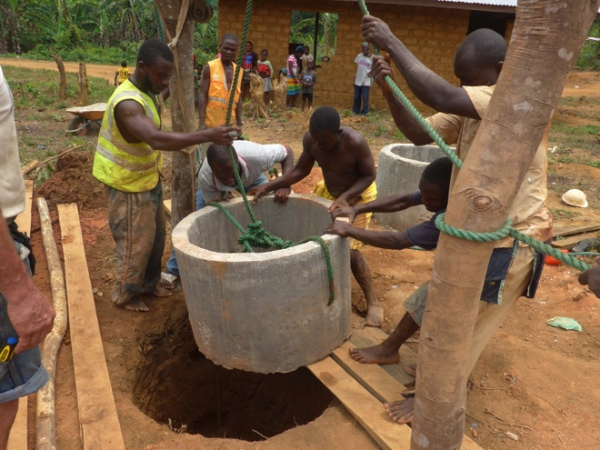
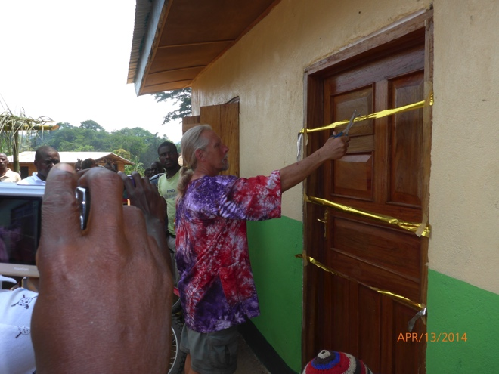

The following Litany or a similar prayer may be offered in worship as part of a celebration of the Kuwaa Mission 5th Anniversary.

Litany of Celebration & Thanksgiving for the Kuwaa Mission

Leader: God the Creator, maker of heaven and Earth,
Congregation: Have mercy on us.
Leader: God the Son, Redeemer of the world,
Congregation: Have mercy on us.
Leader: God the Holy Spirit, Sanctifier of the Faithful,
Congregation: Have mercy on us.
Leader: Holy, blessed, and glorious Trinity, one God,
Congregation: Have mercy on us.
Leader: That it may please you to have your church go into all the world to help others so that the name of Jesus may be known and worshipped by all peoples,
Congregation: We beseech you to hear us, O Lord.
Leader: That it may please you to awaken a zeal for missions in the hearts of all your people,
Congregation: We beseech you to hear us, O Lord.
Leader: That it may please you to send out laborers into your harvest,
Congregation: We beseech you to hear us, O Lord.
Leader: That it may please you to kindle within your people an awareness of mission and a willingness to provide faithful support,
Congregation: We beseech you to hear us, O Lord.
Leader: That it may please you to bless the mission work of all who labor with few resources and great challenges,
Congregation: We beseech you to hear us, O Lord.
Leader: That it may please you to provide safe drinking water; clinics for medical care; scholarships for technicians, nurses, and evangelists; training for well and filter care; and school supplies and Christian education for the people of the Kuwaa Chiefdom in Liberia, West Africa.
Congregation: We beseech you to hear us, O Lord.
Leader: For the health and safety of missionaries and volunteers with the Kuwaa Mission who bring expertise, encouragement and education to the Kuwaa people.
Congregation: We beseech you to hear us, O Lord.
Leader: For an increase in evangelism and ministries of mercy in our local community and abroad, that all people may come to know and enjoy your blessings,
Congregation: We pray to you, O God. Lord, hear our prayer.
Leader: For greater awareness of and empathy for the needs of all your people throughout the world and the injustices that they endure,
Congregation: We pray to you, O God. Lord, hear our prayer.
All: Amen

Blessings and peace in the name of our Risen Savior,

Rev. Carol George
Congregation Coordinator

