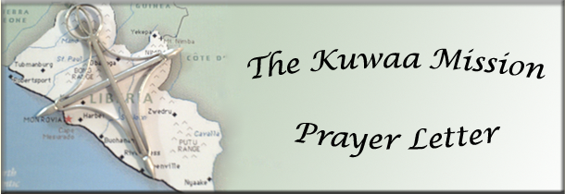

January 2014
5 Years

5-Year Anniversary

Rev. Dr. D. Jensen Seyenkulo and Rev. Dr. Richard Thompson organized the Kuwaa Mission 5 years ago. Since that beginning the Lord richly blessed the Mission’s work program. The Board of Directors grew to 9 members and hundreds of people and congregations joined the ranks of faithful prayer and financial warriors from all over the country.

Just what has the Mission accomplished by God’s grace in these 5 years in mission to the Kuwaa people?

- The Mission constructed or repaired wells in 14 of the 16 villages in the Kuwaa Chiefdom and passed out hundreds of water purification filters.
- God willing the Mission will dedicate the Kondesu Medical Clinic, nurse’s housing and bath house in April. Solar panels are being furnished as well as a toxic waste incinerator and clinic well in April.
- The Mission provides scholarships. Ester Kowula receive a full scholarship to attend nursing school so that she can serve as the clinic’s full time nurse. 3 young men received full scholarships to attend the seminary to become ordained evangelists in the Chiefdom. The Fassama Clinic, schools, and dressers received medical supplies from the Mission each year.
- Workshops were held for pubic and church school teachers, also for evangelists, town pastors, Sunday School teachers, and church leaders. Several workshops were held for people to be trained in the need for sanitation and drinking good water, especially for the children and workshops for learning how to care for the well equipment and water purification filters.
- The mission also provided books, equipment, materials, and religious materials as well as hygiene information.
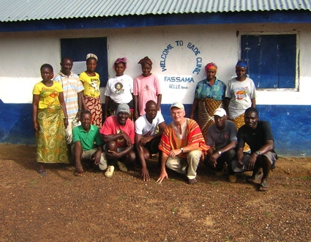
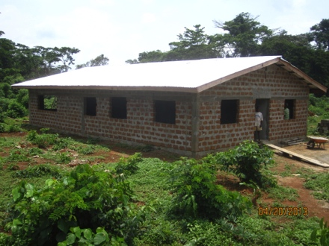
- For all this we give all glory to God as the Kuwaa Mission celebrates its 5th anniversary this year. The Mission also gives thanks to God for you, our faithful prayer and financial warriors. None of this could be done without you. With you the mission is possible!
Thank you on behalf of the Kuwaa people.
Your brother in Christ,
Ed Stelling, Board member

Donations are appreciated and go directly to the Mission!

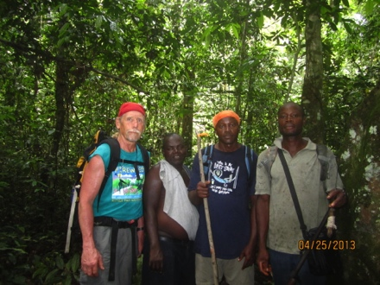
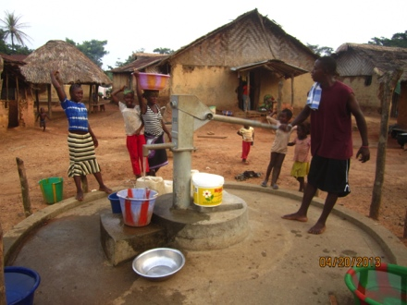
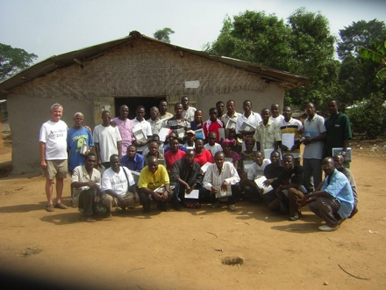

Please visit our Website and our Facebook page for pictures of the work that your donations support!
Donations can be given in two ways: Check to the mission address or PayPal on our Website:
The Kuwaa Mission c/o Bethany Lutheran Church 1340 8th Street Slidell, LA 70458

PayPal: www.kuwaamission.org Facebook: Kuwaa-Mission

