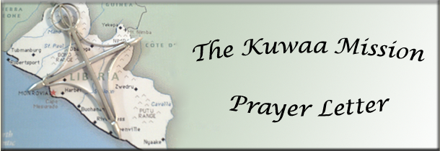

February 2014

As many of you know the Kuwaa Mission operated as a special mission under the auspices of Bethany Lutheran Church - Slidell, LA since its inception in 2009. After waiting 2 years, the Mission acquired its own tax exempt status under Internal Revenue Code Section 501(c)(3) in late 2013. This means that any income the Mission receives will continue to be exempt from state and federal income taxes.
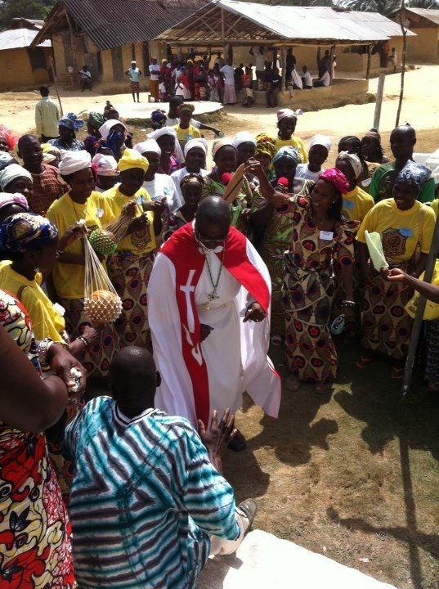
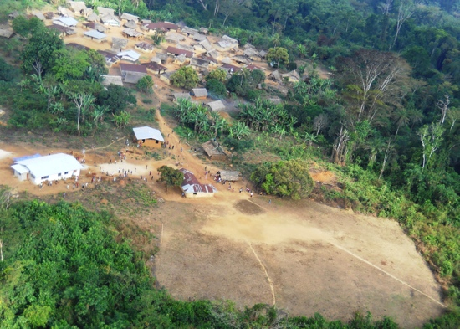
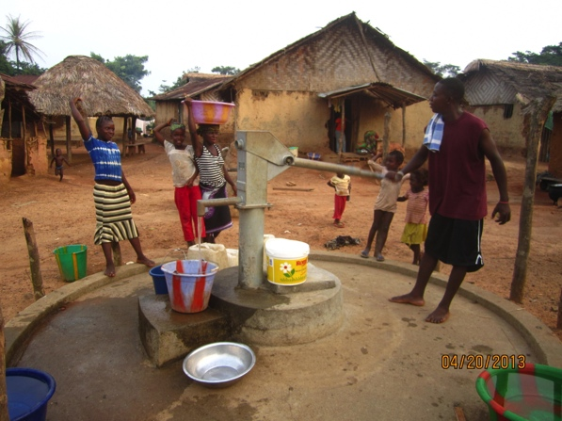
The government will recognize donations sent to the Mission as charitable gifts. They are deductible on your income tax returns, up to 50% of your adjusted gross income. Checks can now be made out to the Kuwaa Mission. Bethany Lutheran Church will continue to be the mailing address. This step is vitally important in being able to receive grants.
Kondesu Clinic – to be dedicated in April.
The Mission appreciates each of you for the support and prayers you offer for the Mission. In the course of a year we receive over $70,000 in support for projects like the Kondesu Medical Clinic, providing potable water by digging wells and supplying water filters. You supported the work of volunteers going to the Kuwaa Chiefdom. Medical and school supplies were purchased and given to the appropriate people. Scholarships helped people complete their education to serve the people through the church or medical clinic. Workshops were held for educators and religious leaders. Most recently a VBS was conducted. Of course, sharing Christ is always foremost. The work of the Kuwaa Mission has not lacked funding. If more funds are received then more work can be done.
We the Board members are very thankful and appreciative of all that God is doing through you and for the Kuwaa people. The Mission also is busy spreading the word about its work. The publicity is a minimal cost but so very necessary if the Mission is to continue its work. The Mission still continues to move forward without having to pay any salaries. We are still 100% volunteer operated.
The Mission appreciates all of you. We thank God for each of you. We also include you in our own personal prayers. It is people like you who make the Mission possible. All the Kuwaa people also thank you as the Spirit is transforming their lives and the providing the necessities they need to live.

Your Brother in Christ,
Ron Morgan – Treasurer & Board Member
Certified Public Accountant

Please visit our Website and our Facebook page for pictures of the work that your donations support!
Donations can be given in two ways: Check to the mission address or PayPal on our Website:
The Kuwaa Mission c/o Bethany Lutheran Church 1340 8th Street Slidell, LA 70458

PayPal: www.kuwaamission.org Facebook: Kuwaa-Mission

