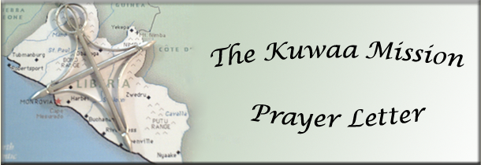

December 2013 2013

Advent Promise

Advent, the 4 weeks preceding Christmas in the church calendar, is my favorite time of the year. Living in Alaska, these are among the coldest, longest, darkest days of winter. It can be a difficult time for many who suffer from a clinical psychological disorder known as SAD (Seasonal Effective Disorder) or who are dealing with loss or grief. In the midst of this darkness the prophet Isaiah speaks a word of hope…

…that time of darkness will not go on forever. The people who walk in darkness will see a great light.
For those who live in a land of deep darkness, a light will shine.
Isaiah 9:1a, 2
In my congregation these past few months have been a time of exceptional loss. I performed six funerals in three months. Many beloved friends and family are now missing from our fellowship and their absence is felt profoundly. Through the darkness of loneliness and grief, Isaiah’s words speak hope..
For a child is born to us, a son is given to us. The government will rest on his shoulders
And he will be called: Wonderful Counselor, Mighty God, Everlasting Father, Prince of Peace.
Isaiah 9:6
The Lord, the Messiah, is coming! In Him is the hope of the nations… hope for peace, for justice, for health and for liberation. And as children of God, we are ambassadors of peace, justice, health and liberation. We are called to speak out, as Isaiah did, the Good News of hope, reconciliation, justice and peace delivered to the world as a baby in a manger in Bethlehem.
For those of us who serve as volunteers, board members, supporters and missionaries to the Kuwaa people, Advent is a time to rejoice in the living hope that one day all people will have clean drinking water, sanitary living conditions, and access to medical care along with the Good News of Jesus Christ. It is a time to recommit ourselves to our mission, even as we wait for Jesus’ return and the fulfillment of God’s Kingdom on earth!
I believe these words, a new verse to the old hymn, O Come, O Come Immanuel, sums up our Advent hope:
O come now, living water, pour your grace,
And bring new life to ev’ry withered place;
Speak comfort to each trembling heart:
“Be strong! Fear not, for I will ne’er depart.”
Rejoice, rejoice! Take heart and do not fear,
God’s chosen one, Immanuel, draws near.
Barbara Lundblad

Rev. Carol George, Kuwaa Mission Board Member
Donations are appreciated and go directly to the Mission!

Please visit our Website and our Facebook page for pictures of the work that your donations support!
Donations can be given in two ways: Check to the mission address or PayPal on our Website:
The Kuwaa Mission c/o Bethany Lutheran Church 1340 8th Street Slidell, LA 70458

PayPal: www.kuwaamission.org Facebook: Kuwaa-Mission

