Christmas Shopping for the Greatest Gift
By Cindy Bye, CEO

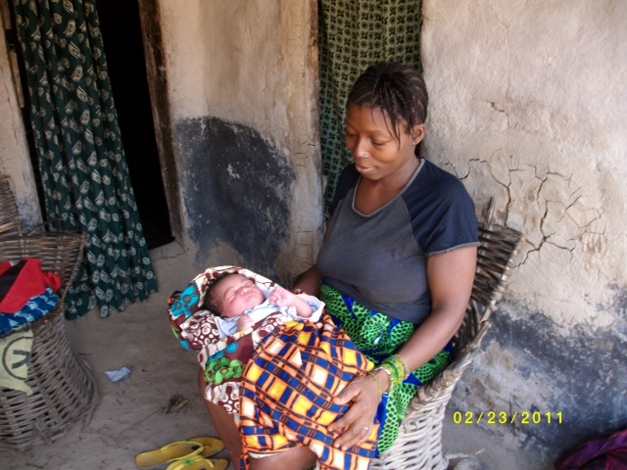
The Christmas season is hectic for many people. Parties to attend, decorations to put up, baking to do, cards to send, and presents to buy. Some people are so hard to buy for, because they have everything they want. Others have everything they need, but they still want more, and no matter how much they have, they’re not satisfied. We are often thankful when it is all over and life is back to normal. Maybe Thanksgiving should be after Christmas!

I once saw a cartoon about a child in the midst of a clutter of wrapping paper and toys with a brightly lit Christmas tree, and the caption, “What a spiritual experience”. That cartoon has stuck with me. Many people forget the Greatest Gift of Christmas. Indeed, many people don’t realize or accept the Greatest Gift.
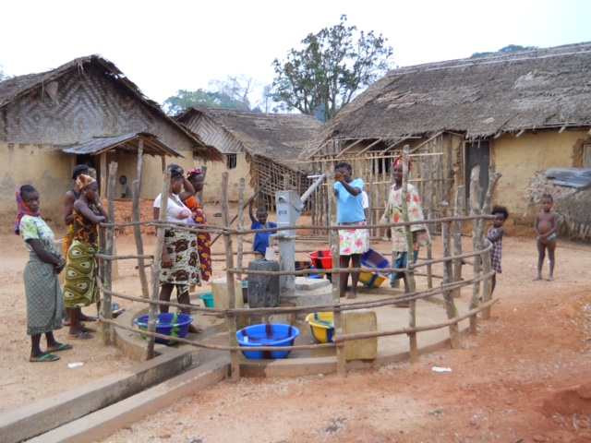
The Kuwaa Christians realize and celebrate the true meaning of Christmas. They do not go out in a frenzy to buy gifts. They don’t spend money they don’t have buying trivial trinkets. And yet, they have so little in the way of material things, that anything that they would receive would be appreciated and needed. They may have a party, and there will be singing and dancing, and mostly praising God for the Greatest Gift they receive.

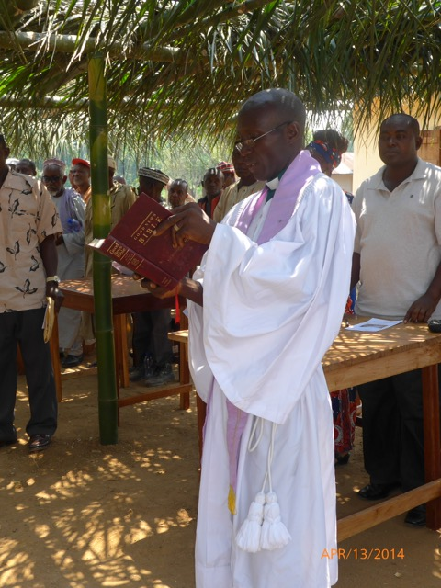
We recently received a note of thank you from the Kuwaa Lutheran Parish Pastor, thanking the Kuwaa Mission for the gifts that you have given to the Kuwaa People. These include clean water, continued support of their two health clinics, Bible School, school supplies, and education. The mission is now sponsoring three men and one woman to attend Evangelist Training, to better serve the spiritual needs of their people. A list of our current programs is attached. The greatest gift that you have given to the Kuwaa People is showing your love for them. They know that you care for them and pray for them. They are very thankful for your gifts and for your prayers. The things they receive are dearly needed and appreciated.

Blessings on your Christmas celebrations.

Heavenly Father,
We thank you for the Greatest Gift you have given us, which was Love personified. Help us to appreciate that gift, and to live out our lives showing love for all of your people. We ask your blessings on the Kuwaa People, as they celebrate Christmas in much simpler ways than we do. We ask that you guide and protect them, and help them feel your love, as well as our love for them.

In Jesus’ name,
AMEN

Kuwaa Mission Programs

Water and Sanitation
- Water wells with hand pumps for safe drinking water. To date, we have provided 22 new wells.
- Provide water filters for stream water.
- Repair multiple wells.
- Train pump technicians.
- Sanitation training.
Basic Health
- New clinic in Kondesu completed in 2014.
- Bringing basic medical supplies to 2 clinics.
Maternal and Child Health
- Participating in the Big Belly Program to inform new parents about giving birth, raising a child, and preventing pregnancy.
- Participating in Days For Girls: providing feminine hygiene packets to young girls. Our goal is to have Days For Girls provide training for women to sew packets by hand for sale.
Spiritual Health
- Children’s Bible School. This is conducted over 2 days with many helpers. We’ve had as many as 240 children attend at once!
- Operation Christmas Child, through Samaritan’s Purse. Bringing shoe boxes and even more importantly, bringing Christian education.
- Providing materials for construction and repair of churches.
Education
- Providing assistance for evangelists to receive training.
- Assisting volunteer school teachers to study for their High School equivalency test.
- Delivering school supplies and books to teachers and students.
- Conducted workshop for public school teachers & Sunday School teachers in 2012.
Bridge Work
- Rebuilding 35 small bridges between the end of the road and the new clinic.

Your contributions to The Kuwaa Mission are tax-deductible. We are a 501c3 non-profit organization. Our Tax ID number is 27-5458111
Donate on our Website or send a Check to the address below. Thank You!
Unsubscribe - Edit your subscription
The Kuwaa Mission: c/o Bethany Lutheran Church, 1340 8th Street, Slidell, LA 70458 www.bethanyslidell.org

