FACE-TO-FACE
Once again, the time has come for the Kuwaa mission board members to assemble for their face to face meeting. This year’s meeting took place in the Beautiful State of Alaska in the city of Anchorage. We met at St Mark Lutheran Church. Much business was discussed to include our bylaws and operational procedures. There was also much discussion about the future of the Mission, along with the discussion of new and existing projects. There was also discussion about the new members coming in and members whose time has come to an end. We are looking forward to new Kuwaa Mission board members being announced soon. There can’t be enough said about all the past and present board members who have given their undivided time, talent, and commitment to the Kuwaa Mission. To say thank you is not enough, but we say thank you anyway and God bless each one from the C.E.O to the volunteers and pray partners, and supporting church congregations. Thanks for all you do on behalf of the Kuwaa Mission.
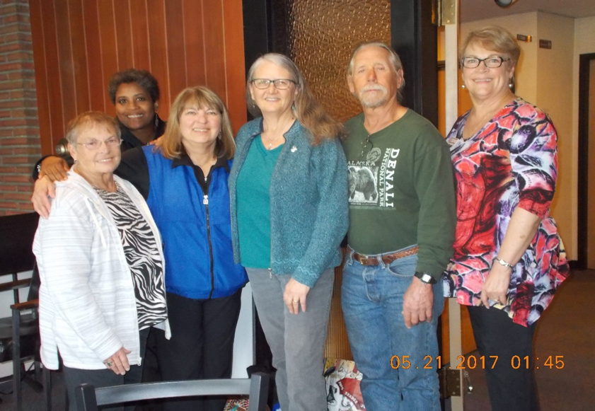

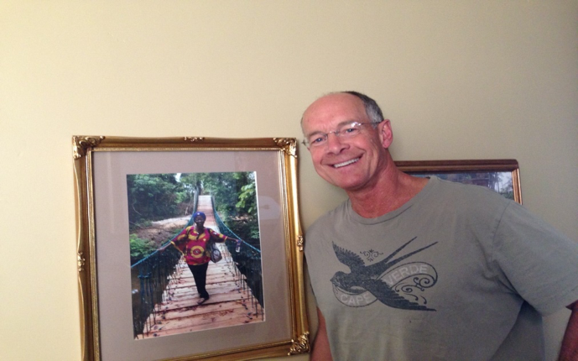
- New and upcoming projects YOU might be interested in:
- Big Belly project (important prenatal care in the bush)
- Operation Christmas Child (Samaritans purse)
- Day’s for Girls (Female hygiene kits)
- Committee assignments (voluntaries)
We are excited and look forward to working with you please come and join us.
Hope everyone had a safe and wonderful 4th of July

OUR NEXT NEWS LETTER WILL BE SEPT 2017
Have a Happy and Fun Summer.

Please pray for Dick & Doris as they are trying to sale their home.
Please pray for Ed & Diane Stalling & Pastor Carol George for a speedy recovery.

Your contributions to The Kuwaa Mission are tax-deductible. We are a 501c3 non-profit organization. Our Tax ID number is 27-5458111
Donations can be given in two ways:
1. Make out check to: The Kuwaa Mission (send to Bethany Lutheran Church (see below))
2. Go to the Kuwaa Mission Website at www.kuwaamission.org: use PayPal to make a one time or automatic monthly donation
Unsubscribe - Edit your subscription
The Kuwaa Mission: c/o Bethany Lutheran Church, 1340 8th Street, Slidell, LA 70458 www.bethanyslidell.org

