Chris Kowula – Bringing God’s Word to His People
I met Chris in 1975 at the Vacation Institute for Training in Applied Linguistics held at the University of Liberia by The Institute for Liberian Languages. God pricked his heart about Linguistics. He fell in love with it and wanted to bring God’s Word to his people. In 1976, he began working with the Kuwaa Translation Team. Chris was a quick study and by 1980 the first draft of the Kuwaa Bible translation was completed.

From 1980 on for some time, Chris was persecuted for his faith and thrown in jail. During that time, he taught Bible studies to his fellow inmates. When he was freed he began studying for the ministry. He didn’t want to become a pastor, he wanted the knowledge to help him finish the editing of the Kuwaa Bible with Rev. Dale Federwitz. He had a rough life during the 14-year Civil War, being in and out of prison because he stood up for his faith.
In 2007 The Kuwaa Mission was established by Rev. Dr. Jensen Seyenkulo and Rev. Dr. Richard Thompson. It was a mission to help the Kuwaao get back on their feet after the rebel forces destroyed the Kuwaa Chiefdom. In 2008 Jensen and I asked Chris to work with the Mission. He served as Field Director for two years.

Shortly thereafter he met 3 of the Kuwaa Mission’s volunteers: Stan Olsen who now leads the Mission, Cindy Bye and her daughter, Becky.
Shortly thereafter he became Translation and Literacy Director for the Lutheran Church in Liberia. He was back working with his first love, Translation and Literacy, until he went to gather leaves with Jesus where he will suffer no more.

He and his faithful and loving wife, Jàngá were married in the 70s. She stayed with him through the years of turmoil. One of their children, Ester, studied to become a licensed mid-wife. She is now serving in a Kuwaa Mission built hospital a Kuwaa town, Kondesu.
Chris also serve the Christians in the Kuwaa Chiefdom as a part time pastor. Whenever he was upcountry he would hold worship services and distribute Holy Communion.

Thanks be to God for the wonderful gift he gave to us. Chris was truly a great blessing to the Kuwaa Translation Mission and the Kuwaa (Lutheran) Mission. He was a tremendous blessing to his family, and a wonderful blessing to me.
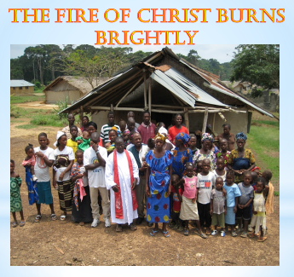
We’ve come his far by faith, leaning on the lord; trusting in his holy word, he has never failed us. Oh, we can’t turn back, we’ve come this far by faith. We’ve come this far by faith. Just remember the good things god has done, things that seemed impossible; oh, praise him for the victory he has won. (“We’ve Come This Far by Faith”, by Albert A. Goodson, 1965)

Please join us in prayer for Chris’ family and for his brother and sisters in the LCL.

In Christ’s love, your brother & Co-Founder of the Kuwaa Mission,
Rev. Dr. Richard Thompson

The Kuwaa Mission is a 501c3 charity, your donations are fully tax deductible and don’t forget to ask your employer about matching donations. Our Tax ID number is 27-5458111

