By Cindy Bye

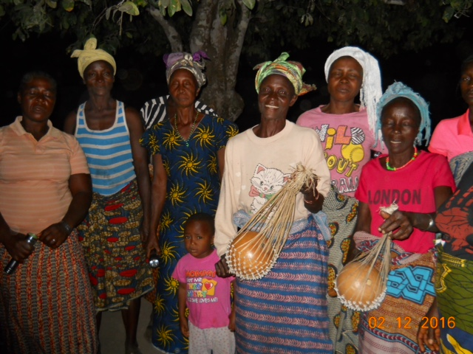
We greet each other in many ways, such as: The Lord be with you. And also with you. Good morning.

The typical Kuwaa greeting is: Mu wuhnee nu veh? Kajeh Ngala deh.

The translation is: How was your sleeping place? Thank God.

The greeting tells us a lot about the Kuwaa People.

They thank God that they woke up this morning. Sometimes, they’ll say, “Thank God for life.”

Last night, I slept on a pillow top mattress in a climate controlled room. I had to go to the bathroom in the night, and it was not uncomfortable. It was only a few steps from the bed, also climate controlled. I sat restfully and after flushing, I won't have to worry about that waste again. My cats sleep on the bed with me, in places of their choosing. They are well cared for -plenty to eat, clean water to drink, a clean bathroom of their own, and vaccines to keep them healthy. I don't have their teeth cleaned, as some pet-owners do, because they don't enjoy traveling to the vet. I once even saw a dog with braces at the vet. His teeth were so crooked it was hard for him to eat. That's a very special dog. An American dog. Oh, the opulent lives we live as Americans. And yet, we find things to complain about.

So, how was your sleeping place? Did any rats run across your bed in the night? Did they eat your ground peas stored in the roof- the fruits of your hard labor that you planned to carry through the jungle for 2 days to the market? Did the wind take your roof off? Did the rain come through the roof? Did everyone in your household wake up alive? If you woke up this morning, then you can thank God.

Sometimes people ask me what I learn from trips to the Kuwaa Chiefdom. There are many lessons. First, I learn gratitude. I thank God for waking me up this morning. I’m thankful for my cozy sleeping place. I’m thankful for the health and safety of my family members. I also learn that if I “Let go and let God”, things will work out better for me than if I try to control my life. I listen to God’s calling and try to do His will. God provides what we need, if not everything that we want. I learn humility. Relationships are so much more valuable than things. I learn that with God, all things are possible. I do not claim credit for the things God has done. To God be the glory. Our God is a mighty God!

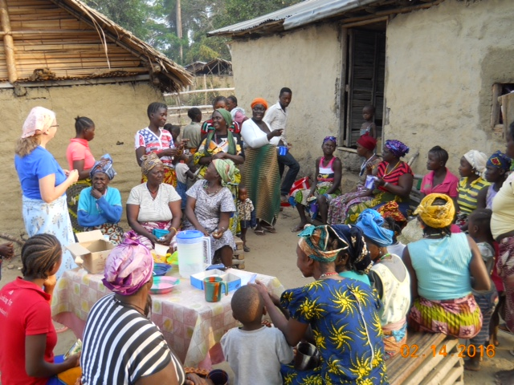
My experiences in the Kuwaa Chiefdom also bring questions to mind. Why is it that people who have so little in the way of material possessions put a high value on their relationship with God? Why are they thankful for their very lives? On the other hand, why do people with so much material wealth lack the spirituality that is much more valuable than all those burdensome things?

I can feel the presence of the Holy Spirit when worshiping with the Liberians, whether in a half hour daily Chapel service at the Lutheran Church in Liberia in Monrovia, a 3-hour New Year’s celebration at a beautiful church, or in a mud hut with a thatched roof. For wherever two or more are gathered in My name, I am there. His presence is felt.

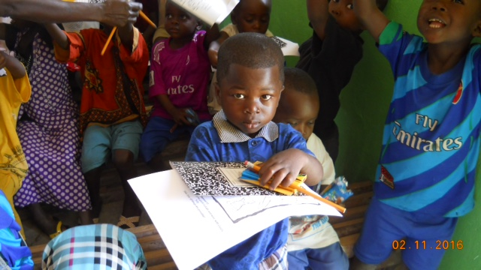
I believe that the Kuwaa people live closer to God than we do. They say that America is the second heaven. And yet, they live much closer to God than we do. They must listen to Him for their very survival. They live only by God’s grace. And still they are thankful. For life.

Go in peace, serve the Lord.

The Kuwaa Mission is a 501c3 charity, your donations are fully tax deductible and don’t forget to ask your employer about matching donations. Our Tax ID number is 27-5458111

