Greetings from Ed Stelling; Kuwaa Mission Advisory Board Member:
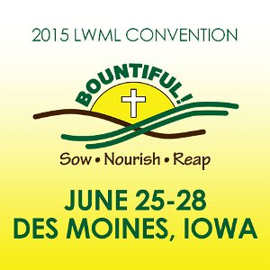
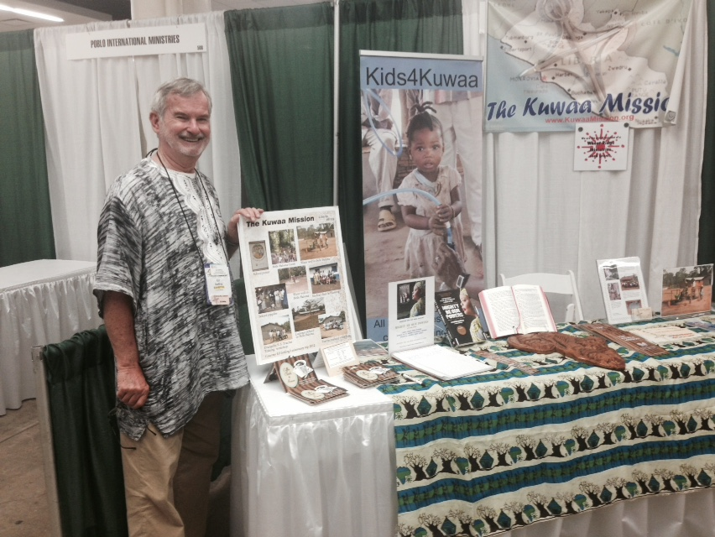
Last month I had the privilege and opportunity to represent the Kuwaa Mission at the biennial International Lutheran Women’s Missionary League (LCMS) convention held in Des Moines, IA. Two years ago, board member Lolitha Shepherd and I attended the convention in Pittsburgh, PA. I met many of the same women and shared the good news of what the mission has accomplished in the past two years: completion of the medical clinic in Kondesu; completion of wells in 14 of the 16 villages; and the VBS conducted in our former village of Belle Baloma several months ago with over 120 children attending. Together we praised the Lord for what has been accomplished.

I also shared with the convention delegates and visitors the current project of our Mission. We are raising funds to help the Kuwaa people to have easier access to the medical clinic from many of the remote villages by building and/or repairing log and plank bridges. These bridges are built for motor bike and foot traffic only at this time. They will also provide easier access for the farmers to transport their rice and other farm produce to market.
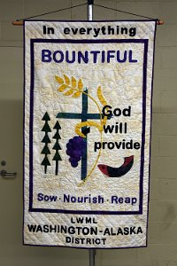
Since the early 1970’s the Kuwaa have had portions of God’s Word and in 1988 the complete Kuwaa New Testament in their own heart language was printed and distributed. The Word of God has been sown, nourished and we have seen the bountiful harvest of souls brought to Christ. Since 2009, the Kuwaa Mission has been involved with the Kuwaa people in helping them to rebuild their lives and villages after the 14-year destructive Liberian civil war. We will, with God’s provision and with the prayers and financial support from our faithful partners carry out this mission and ministry for the Kuwaa. Please consider a donation at this time for the bridge-building projects which begin this November.
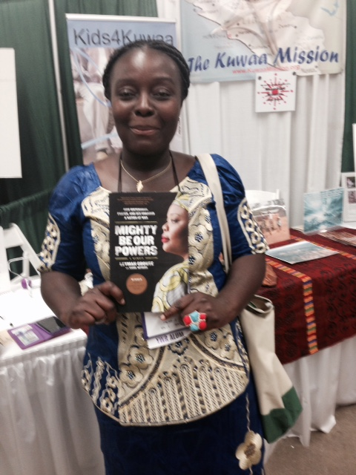
Among the convention delegates that stopped by our display was Lopu, a young Liberian woman living in Delaware. We had met in 2013 at the Pittsburg convention. She entered and won the drawing for the book, “Mighty Be Our Powers,” written by the 2013 Nobel Peace Prize winner, Leymah Gbowee. Leymah is a member of the Lutheran Church in Liberia and was a leader of the women in Liberia bringing an end to the civil war.

Na mama o, tegbele gbaa. (Thank you all very much) on behalf of the Kuwaa people for your continuing prayers and financial support of the Kuwaa Mission.
God bless you all.

