June Prayer Letter by Cindy Bye

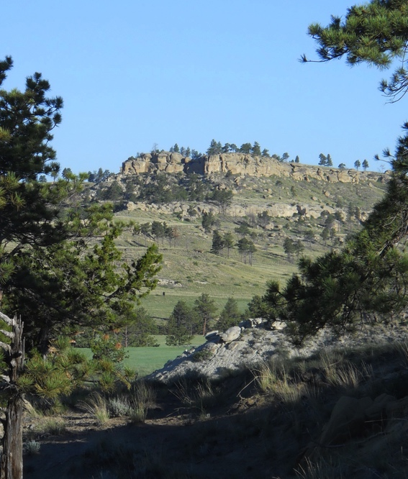
I went for a long walk this morning in the Bull Mountains in central Montana. It was a beautiful warm, partly cloudy day with just enough breeze. I ended up going much further than originally planned. I headed towards a treed knoll across the neighbor’s pasture. Then I saw a ridge off in the distance and wondered what was on the other side. I was inspired by a walk a few weeks ago with Stan, our CEO. He wanted to climb a nearby ridge. I am thankful for the inspiration that he gave me.

We don’t always end up in life where we thought we were going. We sometimes head in one direction and get diverted by an obstacle. Sometimes we use our intuition and the path appears before us. It’s not usually a straight path. It has lots of bends, hills, and valleys. But if we listen to our intuition, it will get us where we are intended to go.

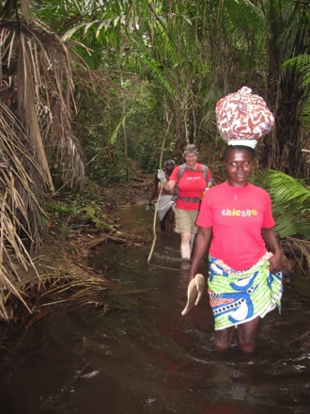
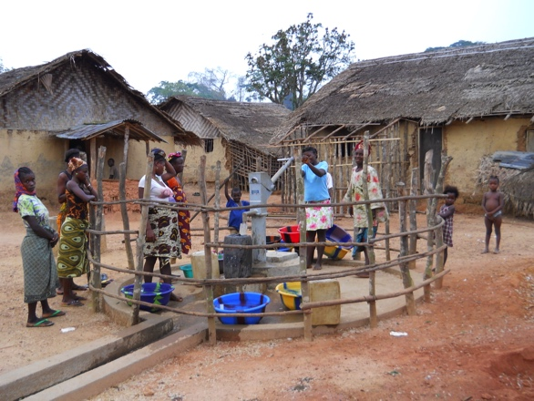
I think about this as my term on the Board of the Kuwaa Mission comes to a close. I initially signed up for a trip to Africa to help people get clean water. I’m an environmental engineer, and I wanted to use my God-given talents to serve others. I heard Rev. Dick Thompson speak about the Kuwaa Mission at my church in Anchorage, and I knew I had to go. I didn’t know that it would lead to spending about 9 months in remote villages over 6 years, and getting to know and to love the Kuwaa People. I was fortunate to see several wells dug, see a clinic built, and do some sanitation training. The highlight was doing Children’s Bible School with 106 kids. It was wonderful to go back year after year and see the improvements in my Kuwaa friends’ lives.

This morning, I thought about the many miles of walking along the well-traveled paths between Kuwaa villages. I felt that if I just walked a little further this morning, I could look over that distant ridge and see the village of Kondesu or Lowuma. I’d see the women and children drawing beautiful clean life-giving water from a well, instead of from the river. I’d see people at the Kondesu Clinic being treated for malaria and getting vaccinations, instead of walking for another 11 hours to the Fassama Clinic. I’d hear the children singing, “Jesus Loves Me”, as they learned in Bible School. All of this became part of my life, because I listened to God’s calling.

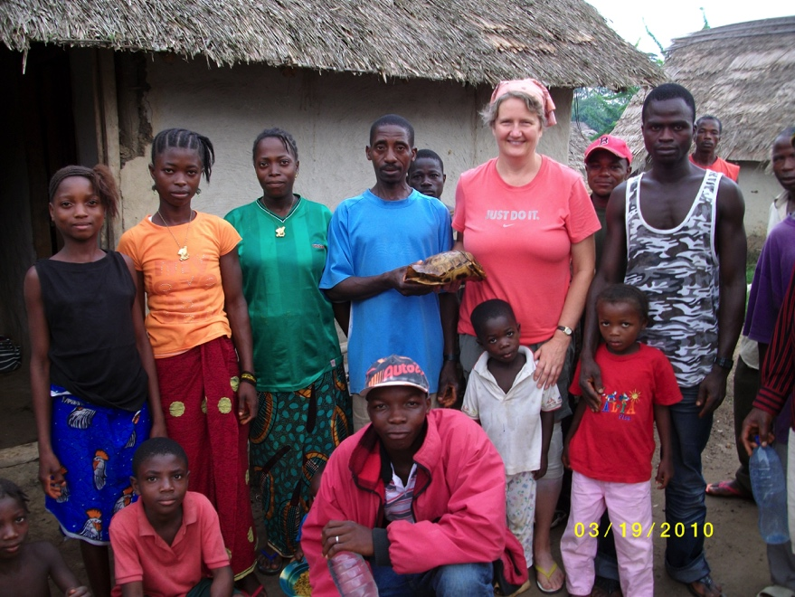
Three Kuwaa Mission Board members will complete their terms at the end of June: me, Ed Stelling, and Ron Morgan. I hope that their journey with the Kuwaa People was as satisfying as mine. I thank them for their service on the Board. We will continue to volunteer for the Mission, but we are turning over the Board positions to 4 new members. Welcome to Karen Kuhnert of North Pole, AK, Carol Norquist of Anchorage, AK, Diane Stelling of Lake Forest, CA, and Karen Voris of Eagle River, AK.

The Board usually meets by teleconference call, but every 2 years, we meet face to face. We recently met in Red Lodge, MT. These meetings are necessary to share our enthusiasm for the Mission, make long term plans, and take care of business issues as a non-profit corporation. We enjoy fellowship together and pray for guidance in steering the Kuwaa Mission towards God’s end goal. It is not a straight path, and there are lots of hills and rivers to cross, but we know that with God all things are possible.

Heavenly Father, we thank you for the work you have done through us to help the Kuwaa People. We ask that you will continue to guide us. Be with our new Board of Directors, all of our volunteers, and our contractors to improve the lives of the Kuwaa People. Be with the Kuwaa People and keep them out of harm’s way. We hear your call, oh Lord. Make straight our pathway.
In the name of the Father, the Son, and the Holy Ghost.
Amen.

