KIDS 4 KUWAA
A Blessed and Happy New Year to our faithful prayer and financial supporters of the Kuwaa Mission. This month we want to share with you some information about the support received from school children at Christ Lutheran Church in Costa Mesa, California. Five years ago the congregation and its school began to support the Kuwaa Mission through various fundraisers and activities informing members about the work of the Mission, especially during the recent Ebola crisis in Liberia.
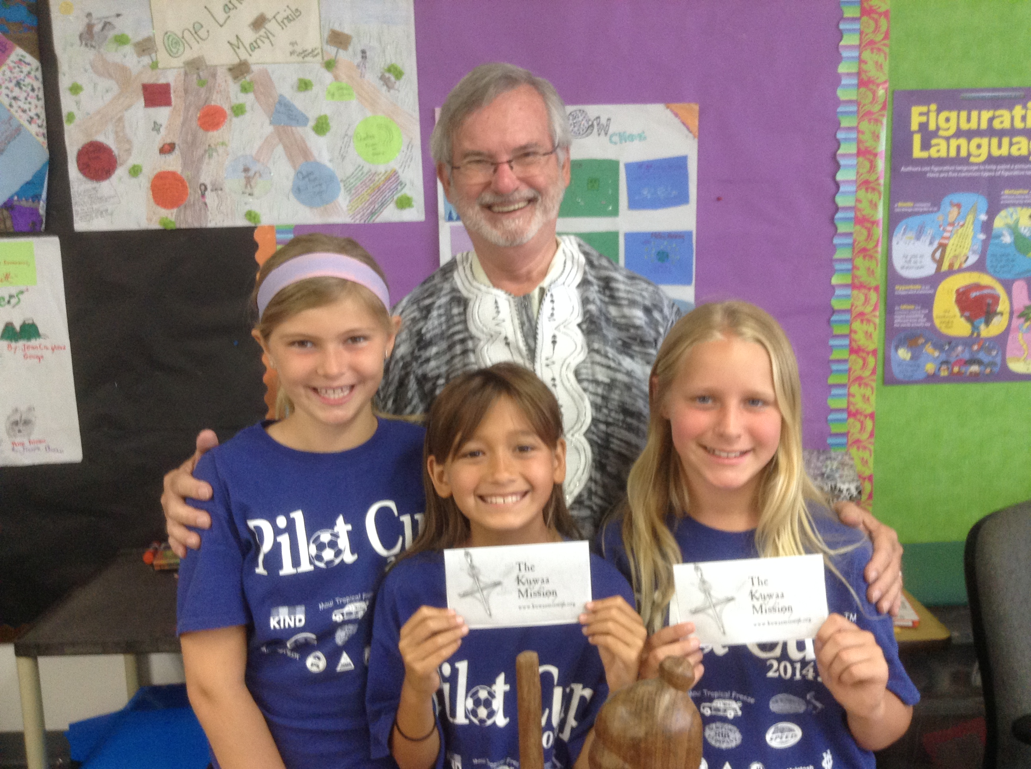
These 3 girls raised over $176 for K4K by making and selling bracelets at church.

Ed and Diane Stelling, Kids4Kuwaa students and school principal Caleb McFerran.
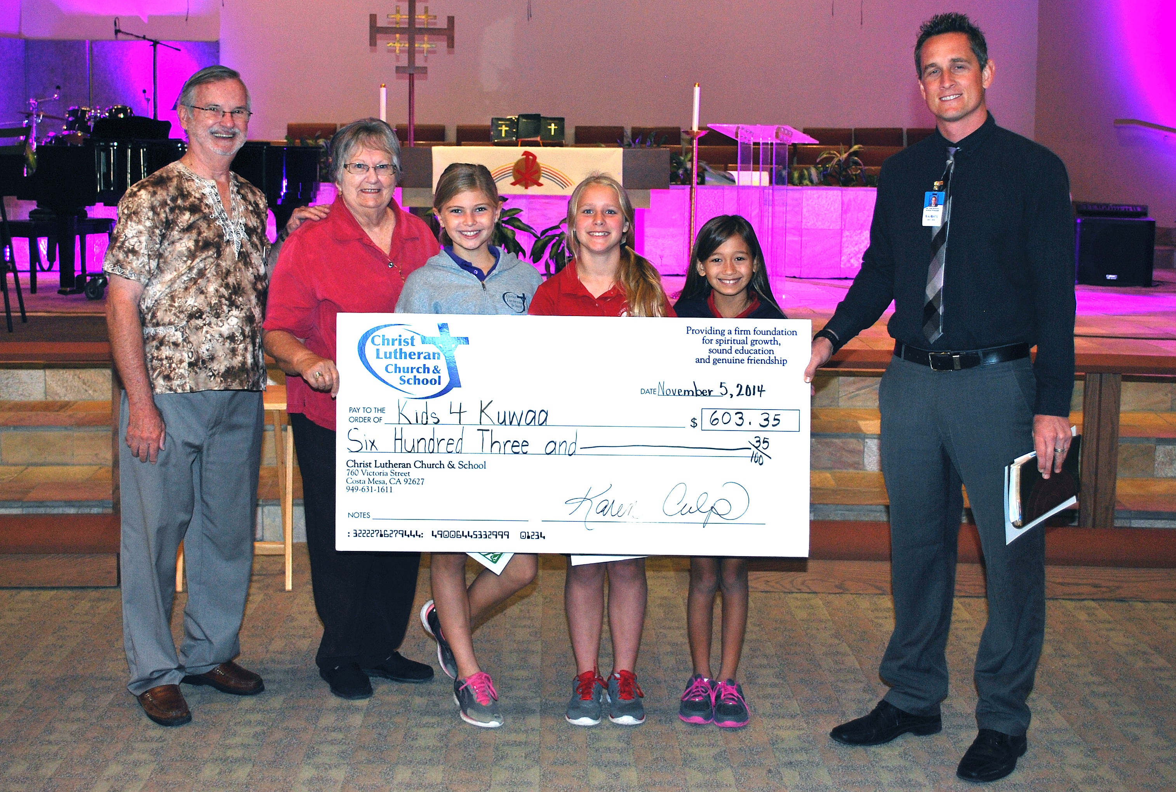
The school children raised $603.35 in the October 2014 weekly chapel offerings.

Na mama o, tegbela gbaa (Thank you, very much, in Kuwaa) boys and girls of our schools and Sunday Schools as you share your love for the Lord with the Kuwaa children. Please continue to pray for the Mission and the Kuwaa children in Liberia.

If your congregation, school or Sunday school would like to get involved, we have Kids4Kuwaa bookmarks and coloring page masters available for children.
Please contact us by email at: estelling@kuwaamission.org

