Greeting to all of our mission partners this sacred season of the year from the Kuwaa Mission. Christmas is typically a season of the year for which we give thanks to our friends, and the Kuwaa Mission has much to be thankful for. Your support is at the top of the list. Without your prayer and financial support the Mission would not have been able to accomplish what it did. What has been accomplished you may ask?
- Distributed over 100 water filters to 16 villages
- Installed 12 wells and rehabilitated many others
- Provided 3 scholarships for “Deacon Training” successfully completed
- Provided one nursing scholarship successfully completed
- Conducted our initial “Teacher Training” workshops
- Conducted two “Water Well Pump Maintenance Training” workshops
- Conducted our initial “Village Sanitation” workshop
- Conducted our initial “Vacation Bible School”
- Built a remote 8 room rural clinic with well and Nurse Quarter to Liberian Health Department standards and turned it over to the Ministry of Health via a Memorandum of Understanding
- Provided support and funds to the Lutheran Church in Liberia and Samaritans Purse in the fight against the Ebola virus
- Provided medicines and medical supplies to the clinics in Fassama and Kondesu as well as midwives in the villages
- Built a strong partnership with the Lutheran Church in Liberia
- Initiated a working relationship between the Lutheran Church of Liberia and the Evangelical Lutheran Church of Liberia
- Earned the respect and trust of the Kuwaa People
- Built a strong working relationship with the Government of Liberia
- Built a strong partnership with Samaritans Purse
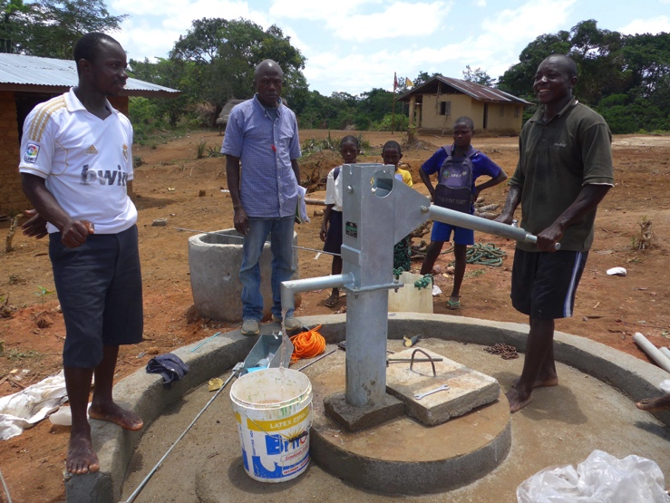
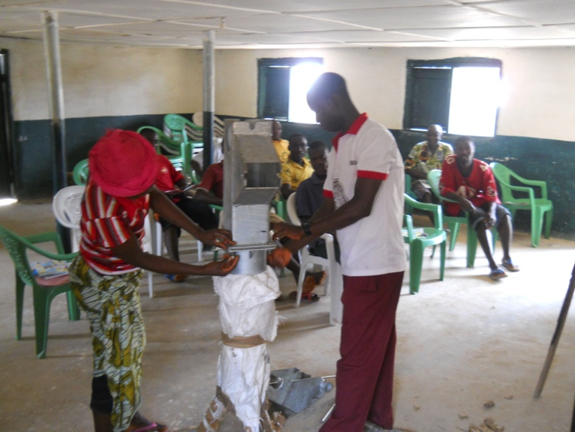

All of these accomplishments were only possible with the financial support of individuals, churches and organizations who believed in the Kuwaa Mission, in its goals and in its capacity to successfully implement its objectives. I urgently request your continued support this year. Each year the Mission has successfully completed its planned work program. The Kuwaa Mission continues to place high expectations on its prayer and financial warriors, and the year 2015 is no exception. This coming year the Kuwaa Mission plans to:
- Rehabilitate the bridges between Fassama and Kondesu to insure that vehicles, especially the Ministry of Health, can travel to the new clinic in Kondesu. This will also enable the continued development of this area of the Kuwaa kingdom. Projected cost $9,500.
- Install three new wells and conduct another well training workshop. Projected cost $29,725
- Conduct another village sanitation program. Projected cost $850.
- Conduct another Vacation Bible School. Projected cost $550.
- The total work program for this year is $40,625.
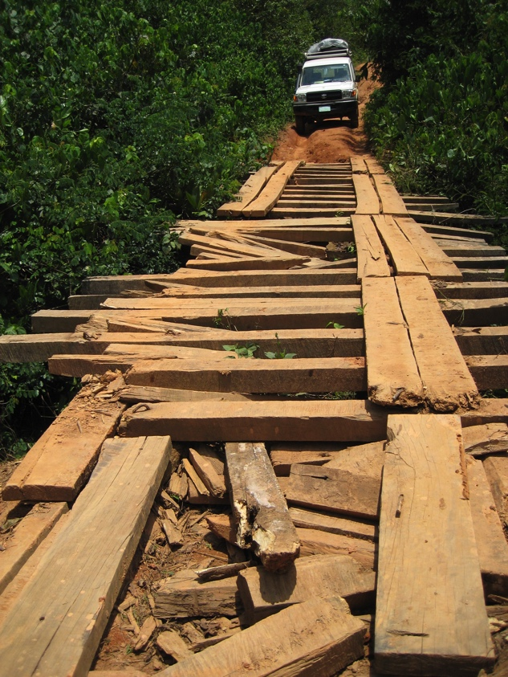
Transportation of people and materials has always been the most expensive part of the Mission’s program and remains our largest challenge. Thanks to our dedicated contractors and Samaritans Purse we have always been successful in overcoming this challenge.

Our balance sheet, while very positive, requires your immediate help to continue our successful record of assistance to this remote area of Liberia and the people who have been neglected by their government. We continue to look to new areas of support and while promising have yet to actually result in funding. Most of us are very fortunate in that we really don’t need “another package under the tree”. However there are thousands in the Kuwaa area that do need “a package” and as the ONLY organization providing help to the people of this area please consider giving a generous donation to the Kuwaa Mission’s General Fund in honor of someone dear to you. Not only will you be honoring someone and letting them know you will be providing assistance to many people who truly need and appreciate your assistance in their difficult lives.

I ask you, as CEO of the Kuwaa Mission, to prayerfully consider the Mission and its work. To keep the work going, during this Christmas season please give to the Kuwaa Mission’s work as generously as possible. Please send all donations to Bethany Lutheran Church to the address as noted below. You can also go to our website www.kuwaamission.org. for “PayPal” donations. It is also very easy to set up automatic monthly payments to the Kuwaa Mission by visiting the website.

Thank you again for your support. From all of the Board of Directors, we pray that you have a truly blessed Christmas season.

Stan Olsen, CEO

