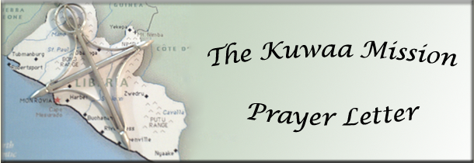

March 2014

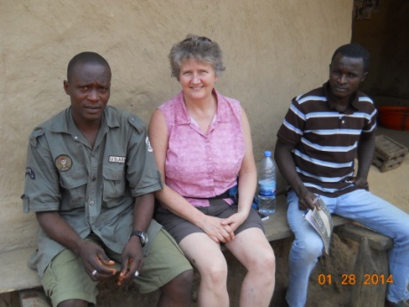
In February 2014, I returned from my fifth trip to Liberia with the Kuwaa Mission. What a pleasure it is to see the Kuwaa People that I have come to know and love. Thanks to all of the Mission supporters for making these trips happen. We are doing great things and changing lives.
Cindy Bye & 2 Kuwaa Friends
We are digging 3 wells this year, in Fassama, Konjade, and at the clinic site in Kondesu. This will bring our total to 15 wells! Praise the Lord! We will continue to dig wells, as each village needs at least 2 wells. The villages are larger than you might think, with the smallest at about 350 people, and the largest at about 3000. The villages look small, because they don’t have a lot of houses. Many people will live in one house. They also don’t have a lot of STUFF, like we have! Why do we have so much stuff? That’s a question I often ask myself.
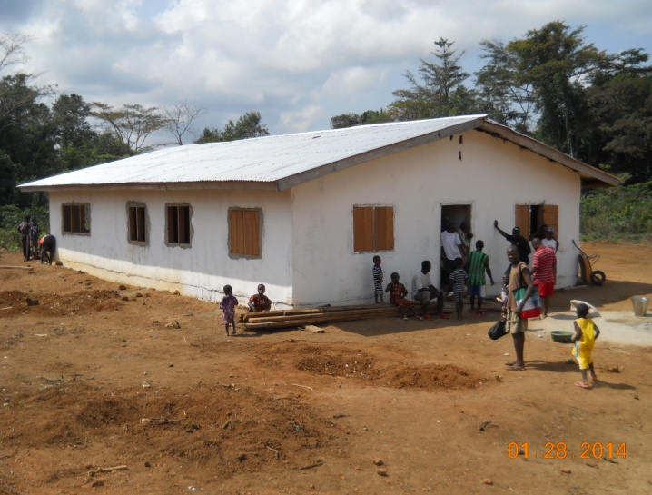
One of the high points of my trip was a visit to the clinic in Kondesu, which is under construction. The clinic and nurses’ quarters will soon be complete. That will be such a blessing to the Kuwaa People, as the only other clinic in the region is over a day’s walk away from some villages. We began planning for the clinic dedication which will take place on April 13, 2014 (Palm Sunday). Stan Olsen, the Kuwaa Mission CEO, will be there. The rest of us will be there in spirit, and we are certainly celebrating!
Kondesu Clinic
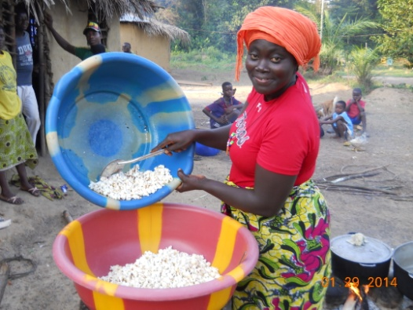
This year, we did a VBS program for the children in Kenata. We called it “CBS” or Children’s Bible School, because the idea of a vacation doesn’t translate well. It was a huge success, with 106 children attending, and about 40 adults. I want to thank Nancy Uptgraft from Fairbanks, AK for all of her help and for the supplies she sent for the CBS. I’m hoping that she can join me next year to bring CBS to another Kuwaa village.
Korpu making Popcorn
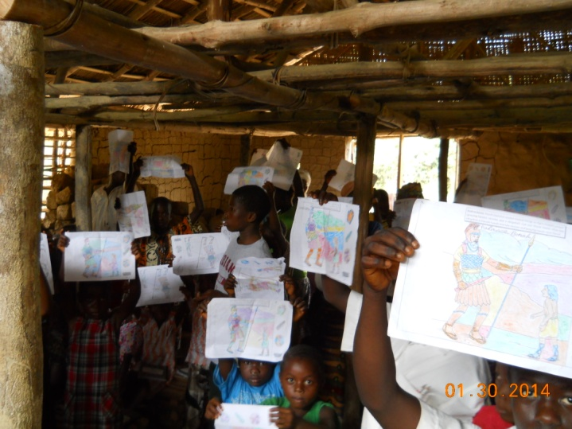
The CBS program covered 2 afternoons, with lessons about David and Goliath and about Jesus’ love for children. The children learned and recited two Bible verses: Psalm 23:6 and John 3:16. Nancy had supplied crayons for each child, and everyone got to color a picture of little David overcoming the giant with God’s help. Even the adults enjoyed the coloring! We also supplied snacks for them, and my helper from Monrovia, Korpu, popped corn for everyone. They were amazed and delighted with that.
Children’s Bible School Class
The whole village participated in the CBS program. We had requested help from the women, and 16 of them volunteered. The three evangelists (Lutheran, Catholic, and Pentecostal) helped, too. To show the women our appreciation, Korpu and I served them tea and biscuits at the conclusion. We read a few Bible passages and let the women know how important they are to the health and happiness of their community. All of the helpers received certificates in their names, which is very popular in Liberia.
We also conducted our first “Community Led Total Sanitation” program in Kenata. This is a UNICEF program designed to incite community leaders to want to clean up their towns, by showing how disgusting and unhealthy their practice of open defecation is. Korpu facilitated the program, as it is necessary to have a native Liberian involved. She did an excellent job, and we want to continue this program.
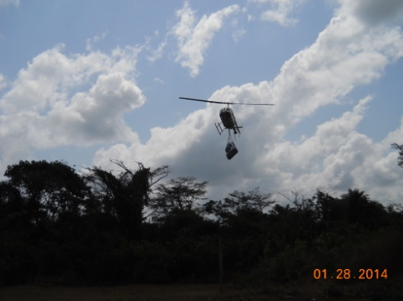
I was absolutely delighted to have transportation by helicopter this year, provided by Samaritan’s Purse. They have been an integral part of our clinic construction. We wouldn’t have been able to do it without them. Thank you so much, Samaritan’s Purse!
Helicopter delivering supplies
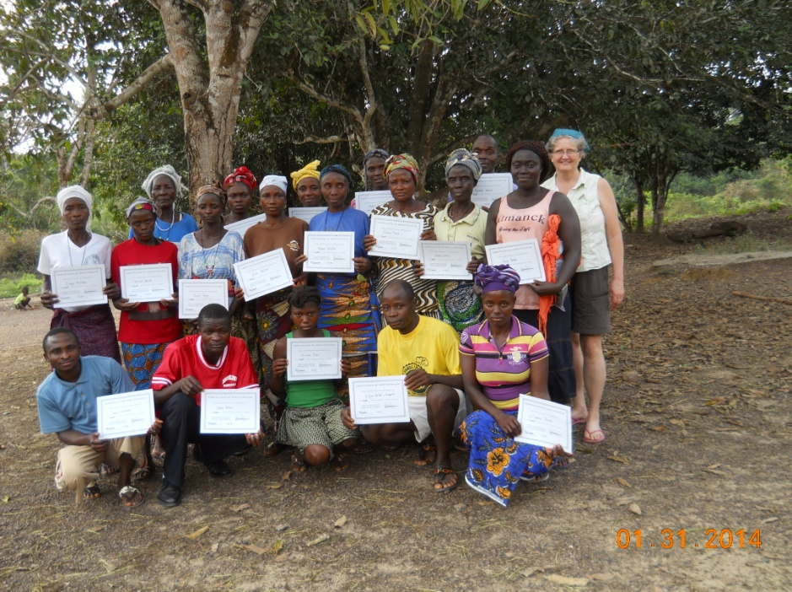
My time in the bush was the highlight of the trip. The Kuwaa People are the reason that the Kuwaa Mission exists! I got to see many of my old friends, and I can see how their lives are improving. I also spent some time in Monrovia carrying out some of the business of the Kuwaa Mission. We try to make contact with government officials and other NGOs working in the area. Life is all about relationships!
Cindy & Christian Bible School Teachers
Again, I want to thank everyone for their participation with the Kuwaa Mission. Thank you for your financial support. Thank you, too, for your prayers – they are powerful!
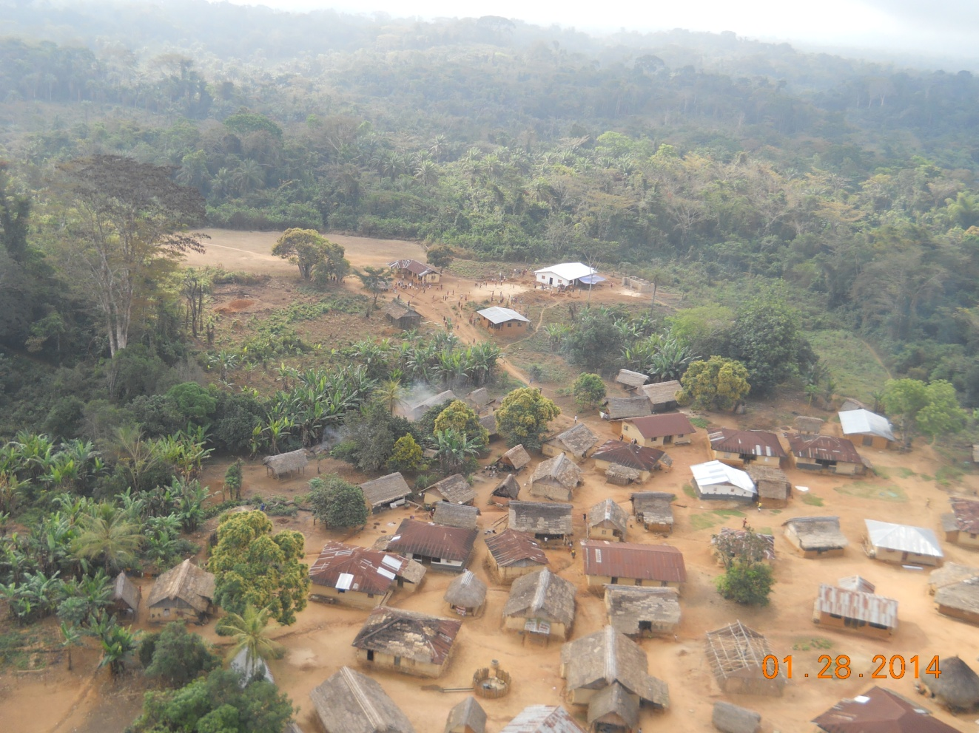
I am lucky to be the messenger, to deliver the Good News, the clean water, the improved health, and particularly hope for a better tomorrow to the Kuwaa People. I am only a messenger, and I don’t take the credit for God’s work through you. To God be the Glory!
The Village of Kondesu
White Building at the Top of the Photo is the Clinic
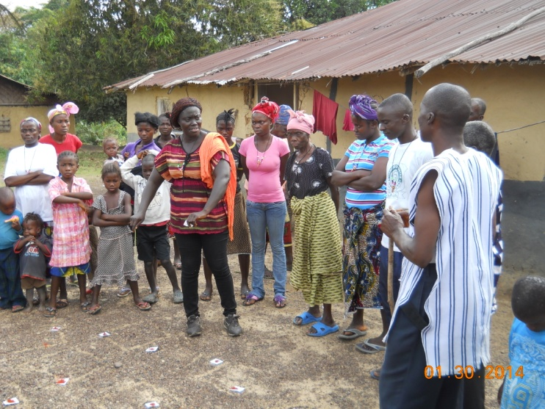
Korpu conducting a Community Led Total Sanitation Program in Kenata.

Blessings,
Cindy Ellis Bye
Kuwaa Mission Volunteer
March 2, 2014

Please visit our Website and our Facebook page for pictures of the work that your donations support!
Donations can be given in two ways: Check to the mission address or PayPal on our Website:
The Kuwaa Mission c/o Bethany Lutheran Church 1340 8th Street Slidell, LA 70458

PayPal: www.kuwaamission.org Facebook: Kuwaa-Mission

